Technical Documentation

# 1. Overview

This file tells the function, information flow, architecture and operations of our web application. You can also find the general idea of our solution in submitted PPT. We have implemented the application managing the whole process from the request sent by client to the completion of the Post-sale service. The whole off-line and on-line processes are integrated in one system and all data well under management. However, as a demo, some functions are simplified. You will see the differences in the 4th part of this file.

# 2. Information Flow



# 3. Software Architecture



# 4.Detailed Operation Procedure

Now we will introduce the detailed operations of our web application. It provides different interfaces and functions for people of different identities. We abstract various roles into four types: client, manager, engineer and tool keeper. Detailed descriptions of interface for each role are as below. You will see all functions here.

## 4.1 Interface for client

Clients of GE can make a request for post-sale service of products bought from GE and check the progress of service at any time. Here are the screenshots and descriptions of client interface in operation sequence.

1. Login from the following page with a client account.

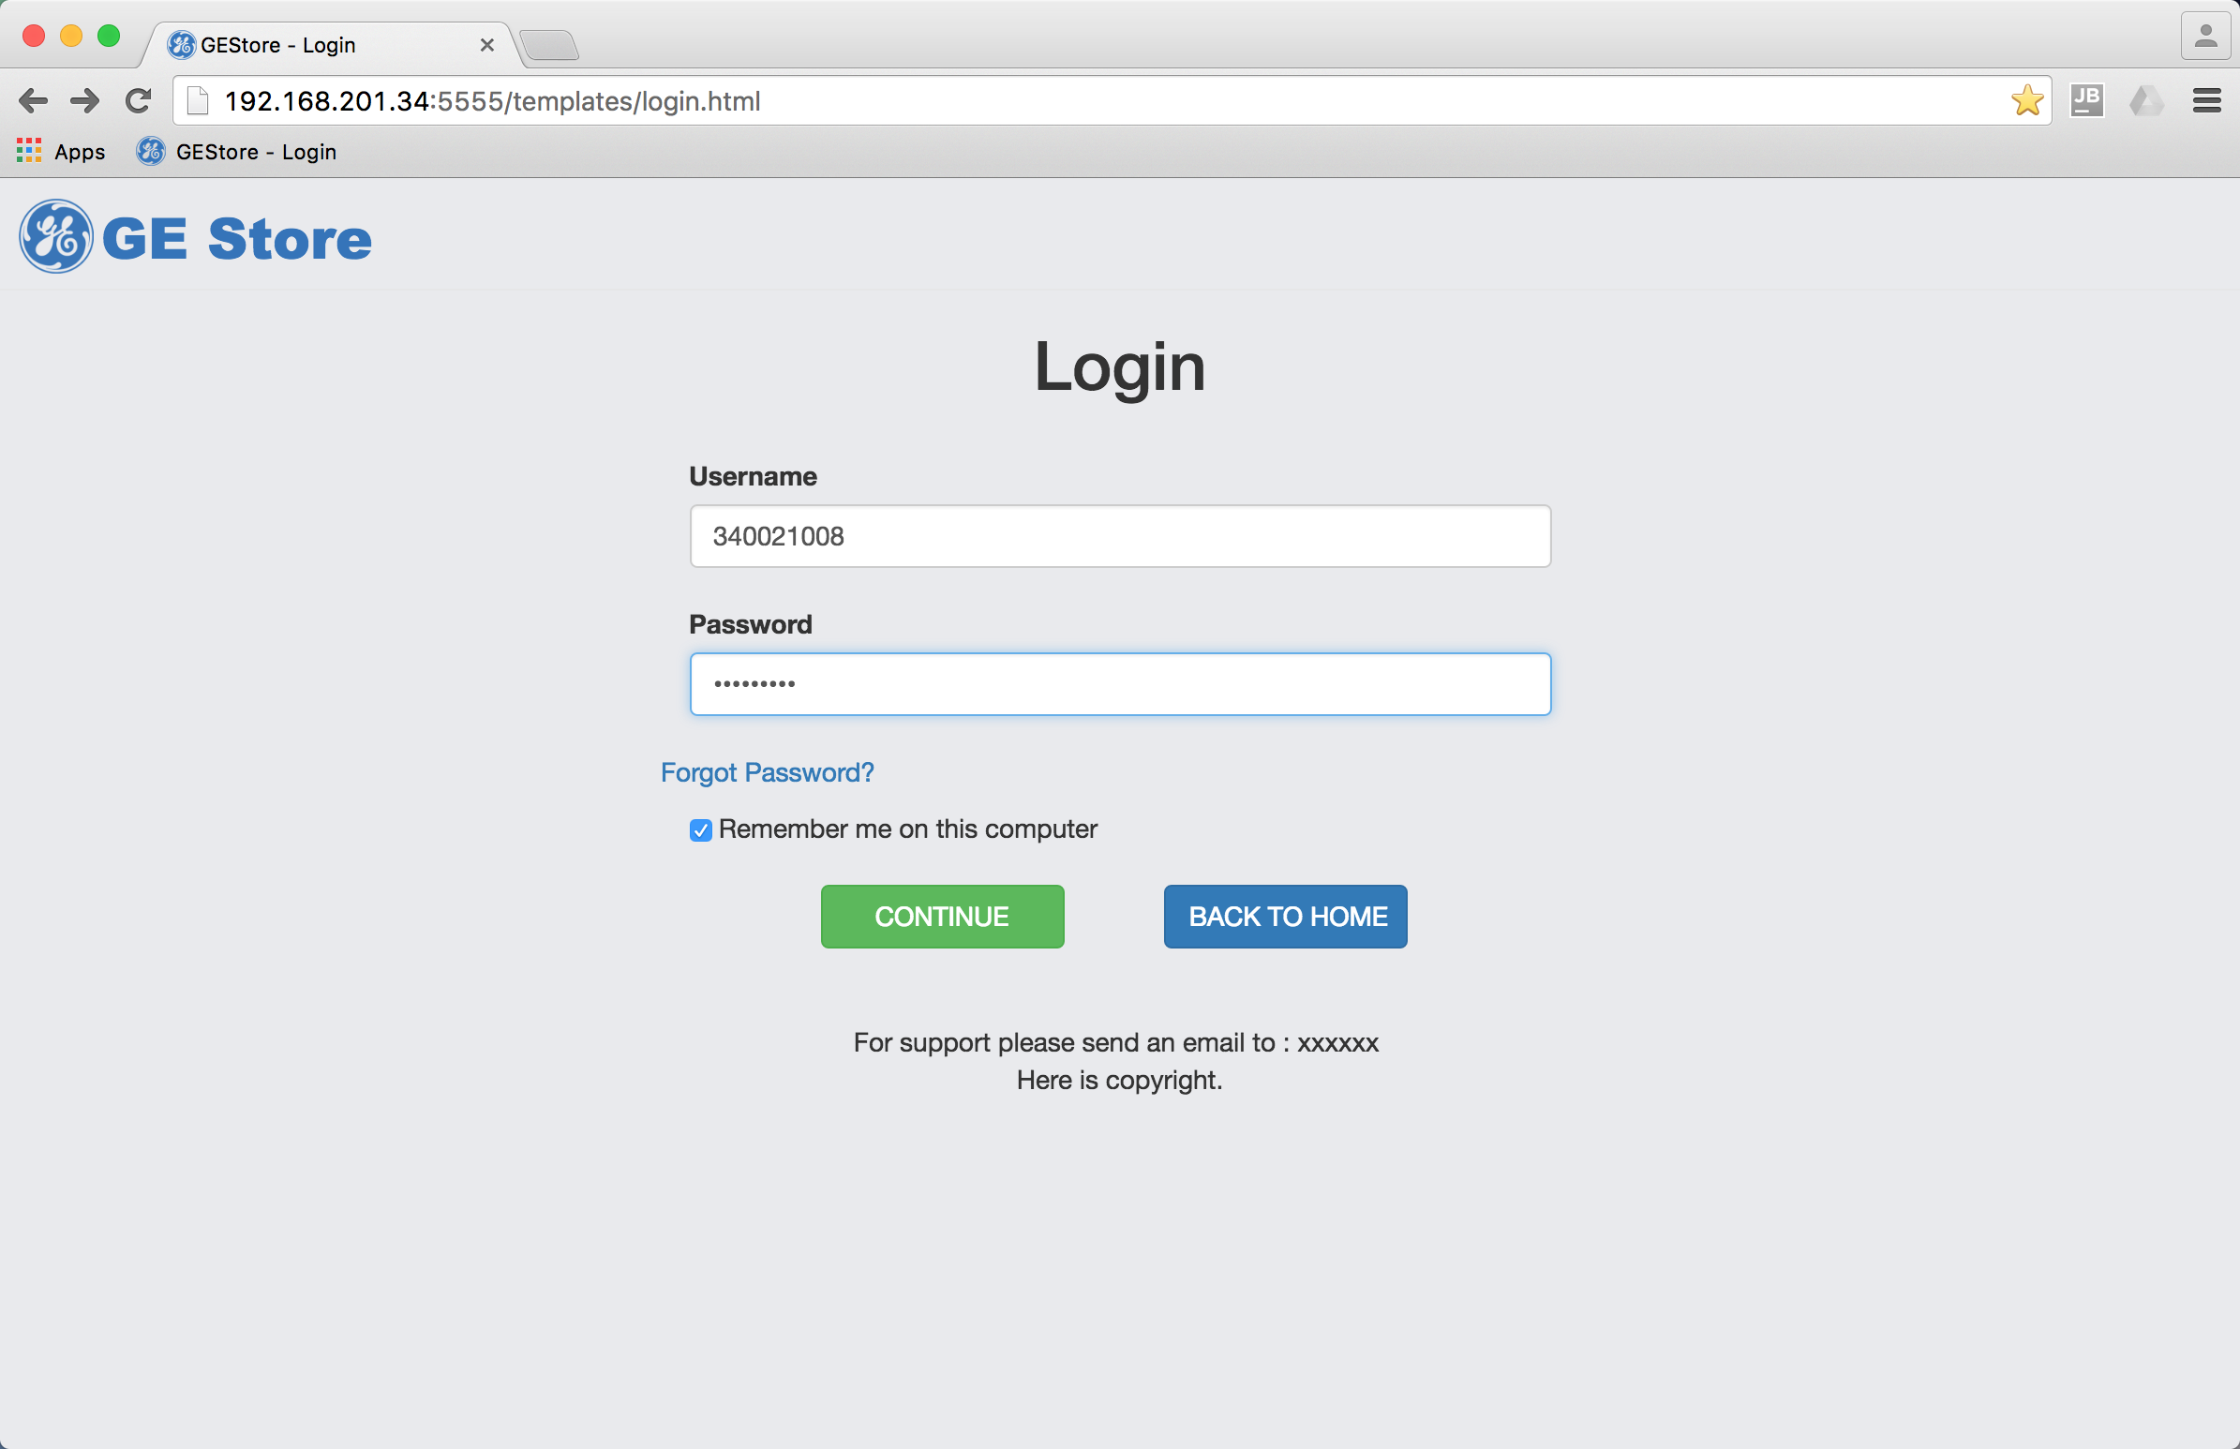

1. The page jumps to personal center of the client, personal information loaded automatically. Click “Make a new request” to ask for post-sale service.

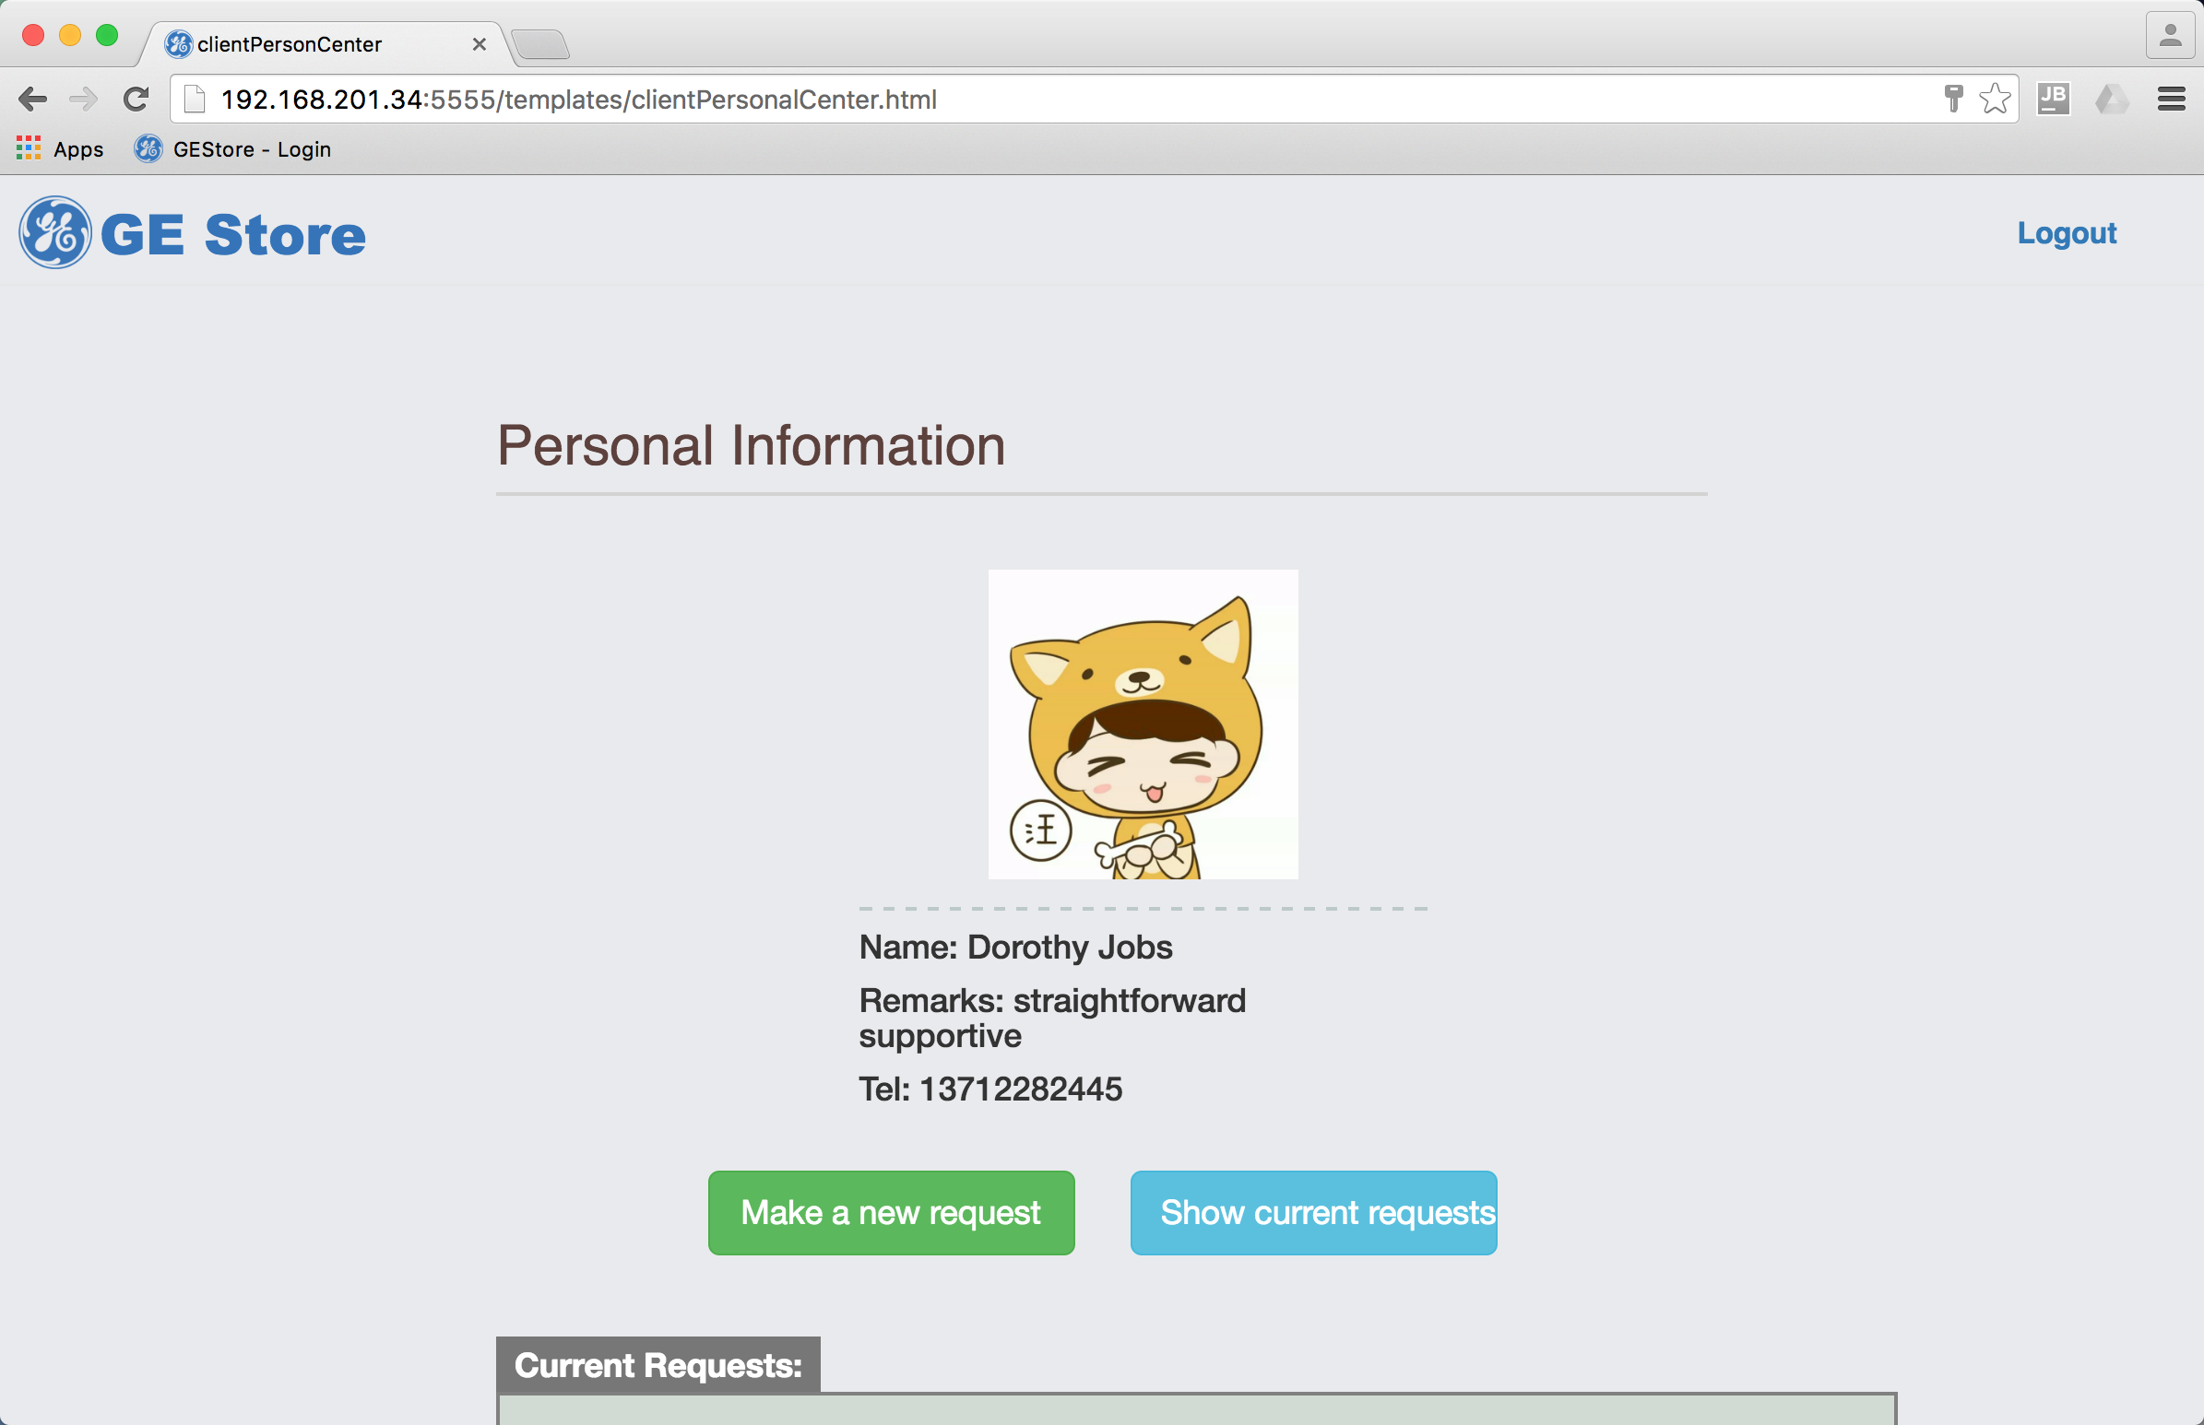

1. Fill in the detailed information of the request, including time, location and problems and click “SUBMIT”. The data will be updated to the server and a new service will be created.

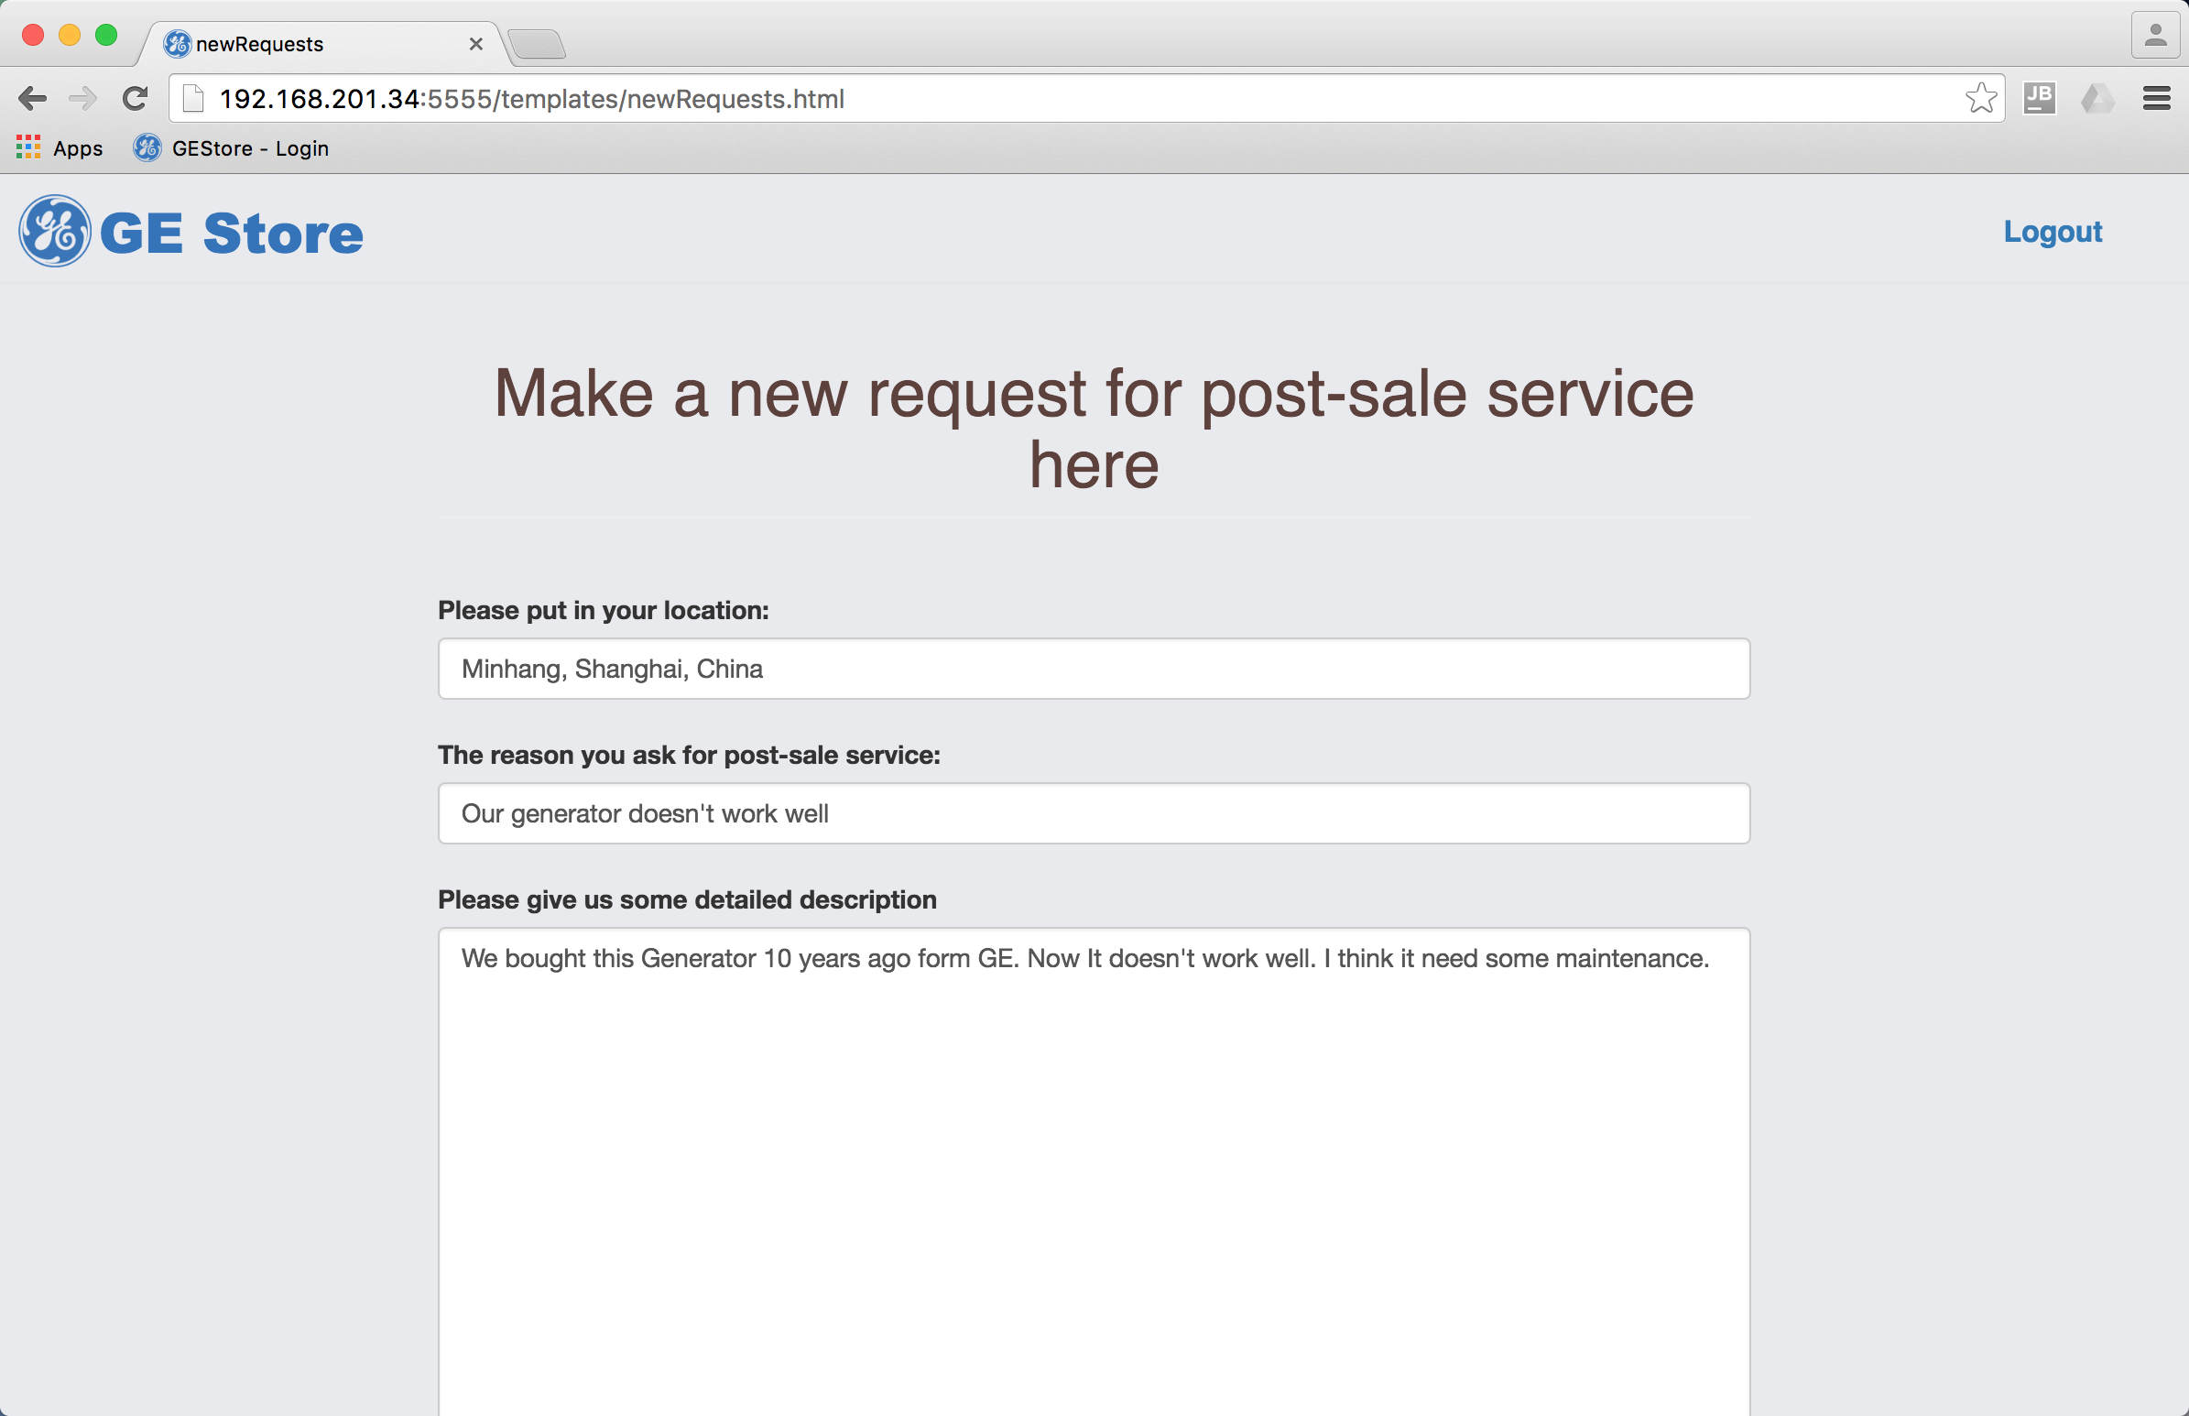 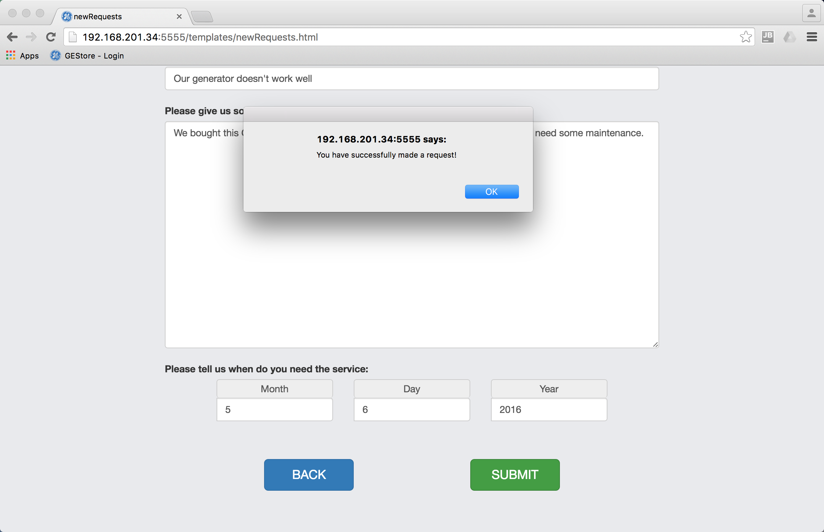

1. Back to the client personal center, click “show current requests[1]” to see the request that has just been made. If there are more than one piece of requests, all can be seen here. Click one of the requests to see details.

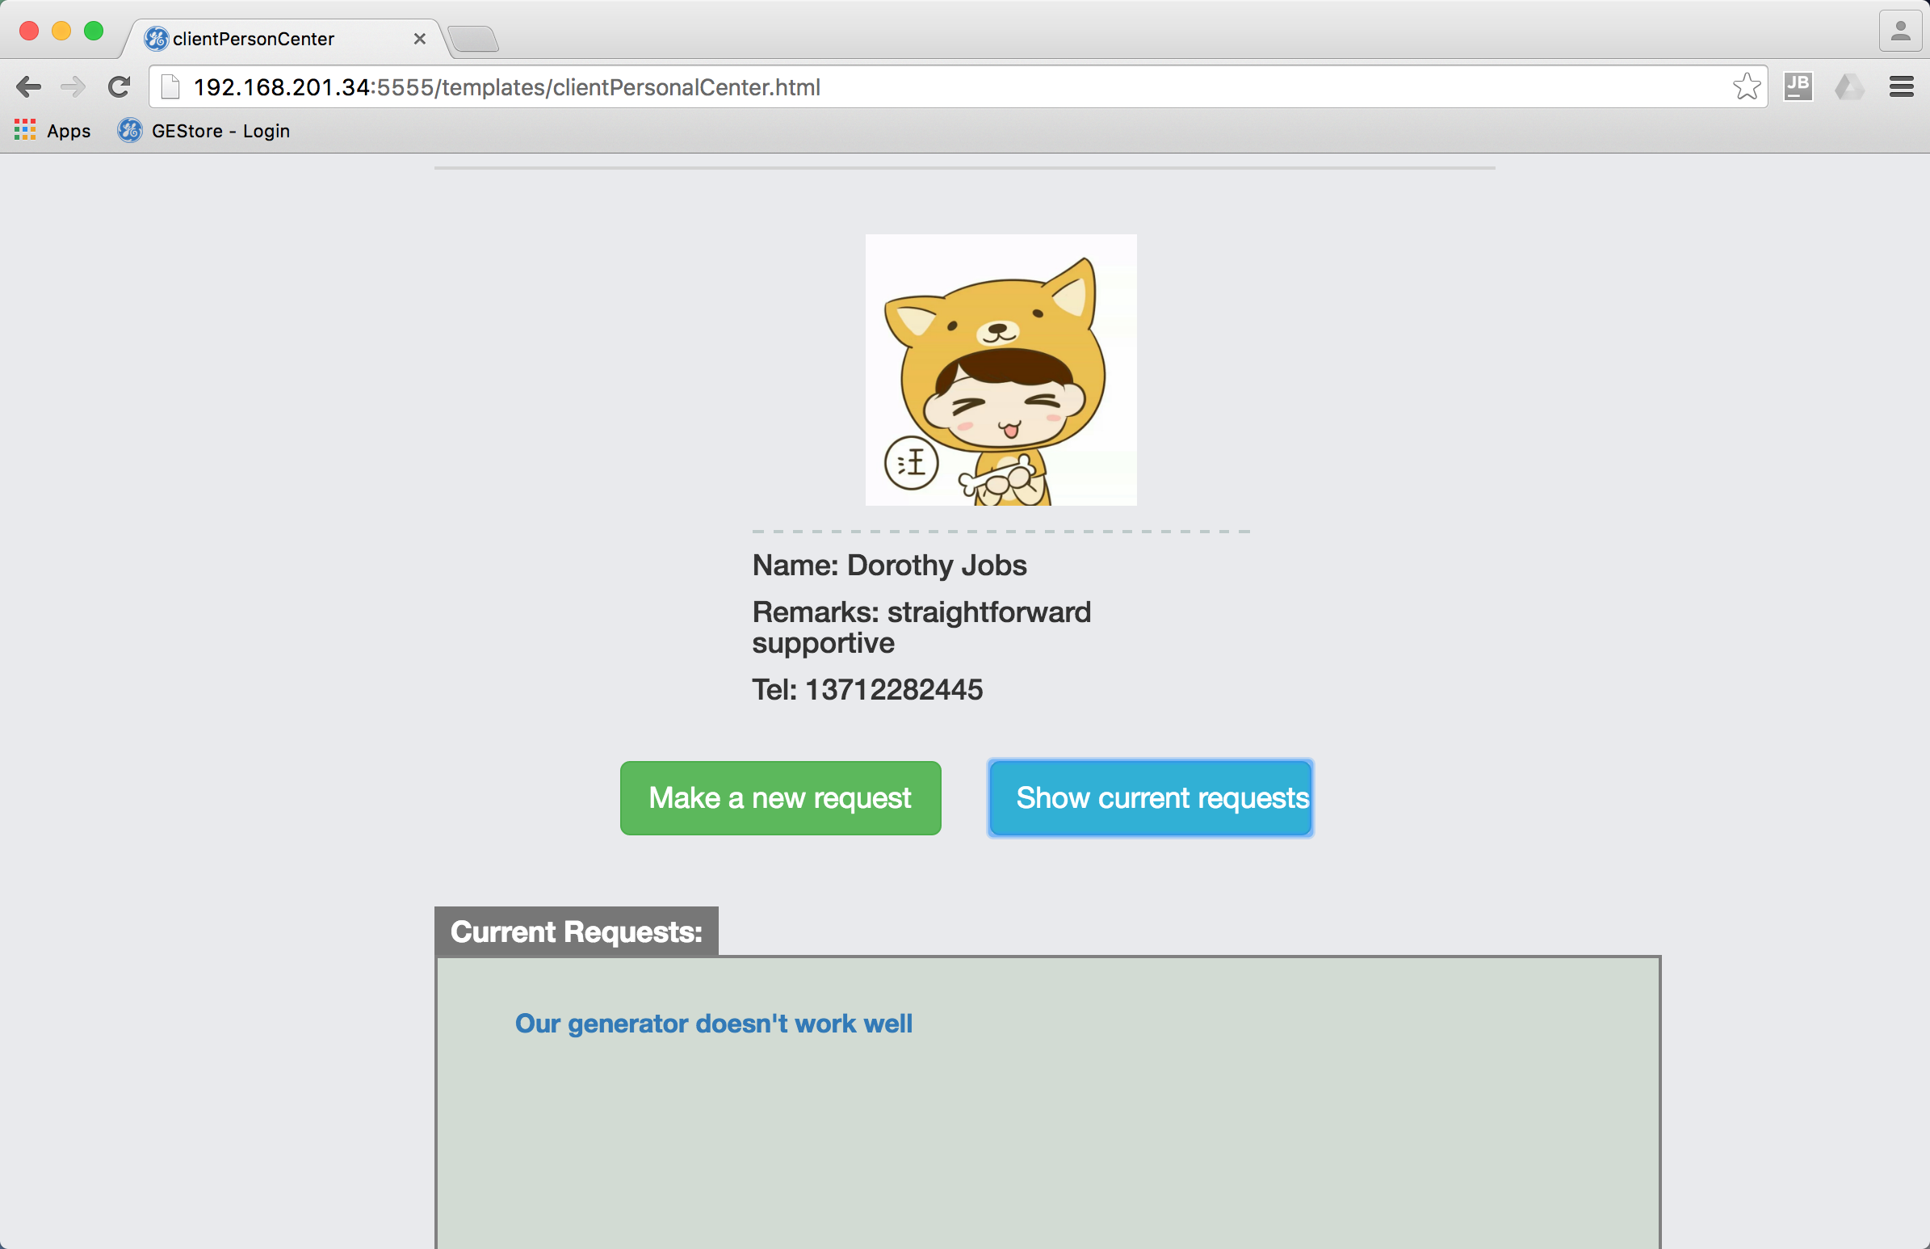

1. The progress of the service is shown in the following page. The client can come to this page at any time to see what GE has done. When engineers finish their work, the “FINISH” button will appear at the bottom of the page for him/her to confirm the completion of the service.

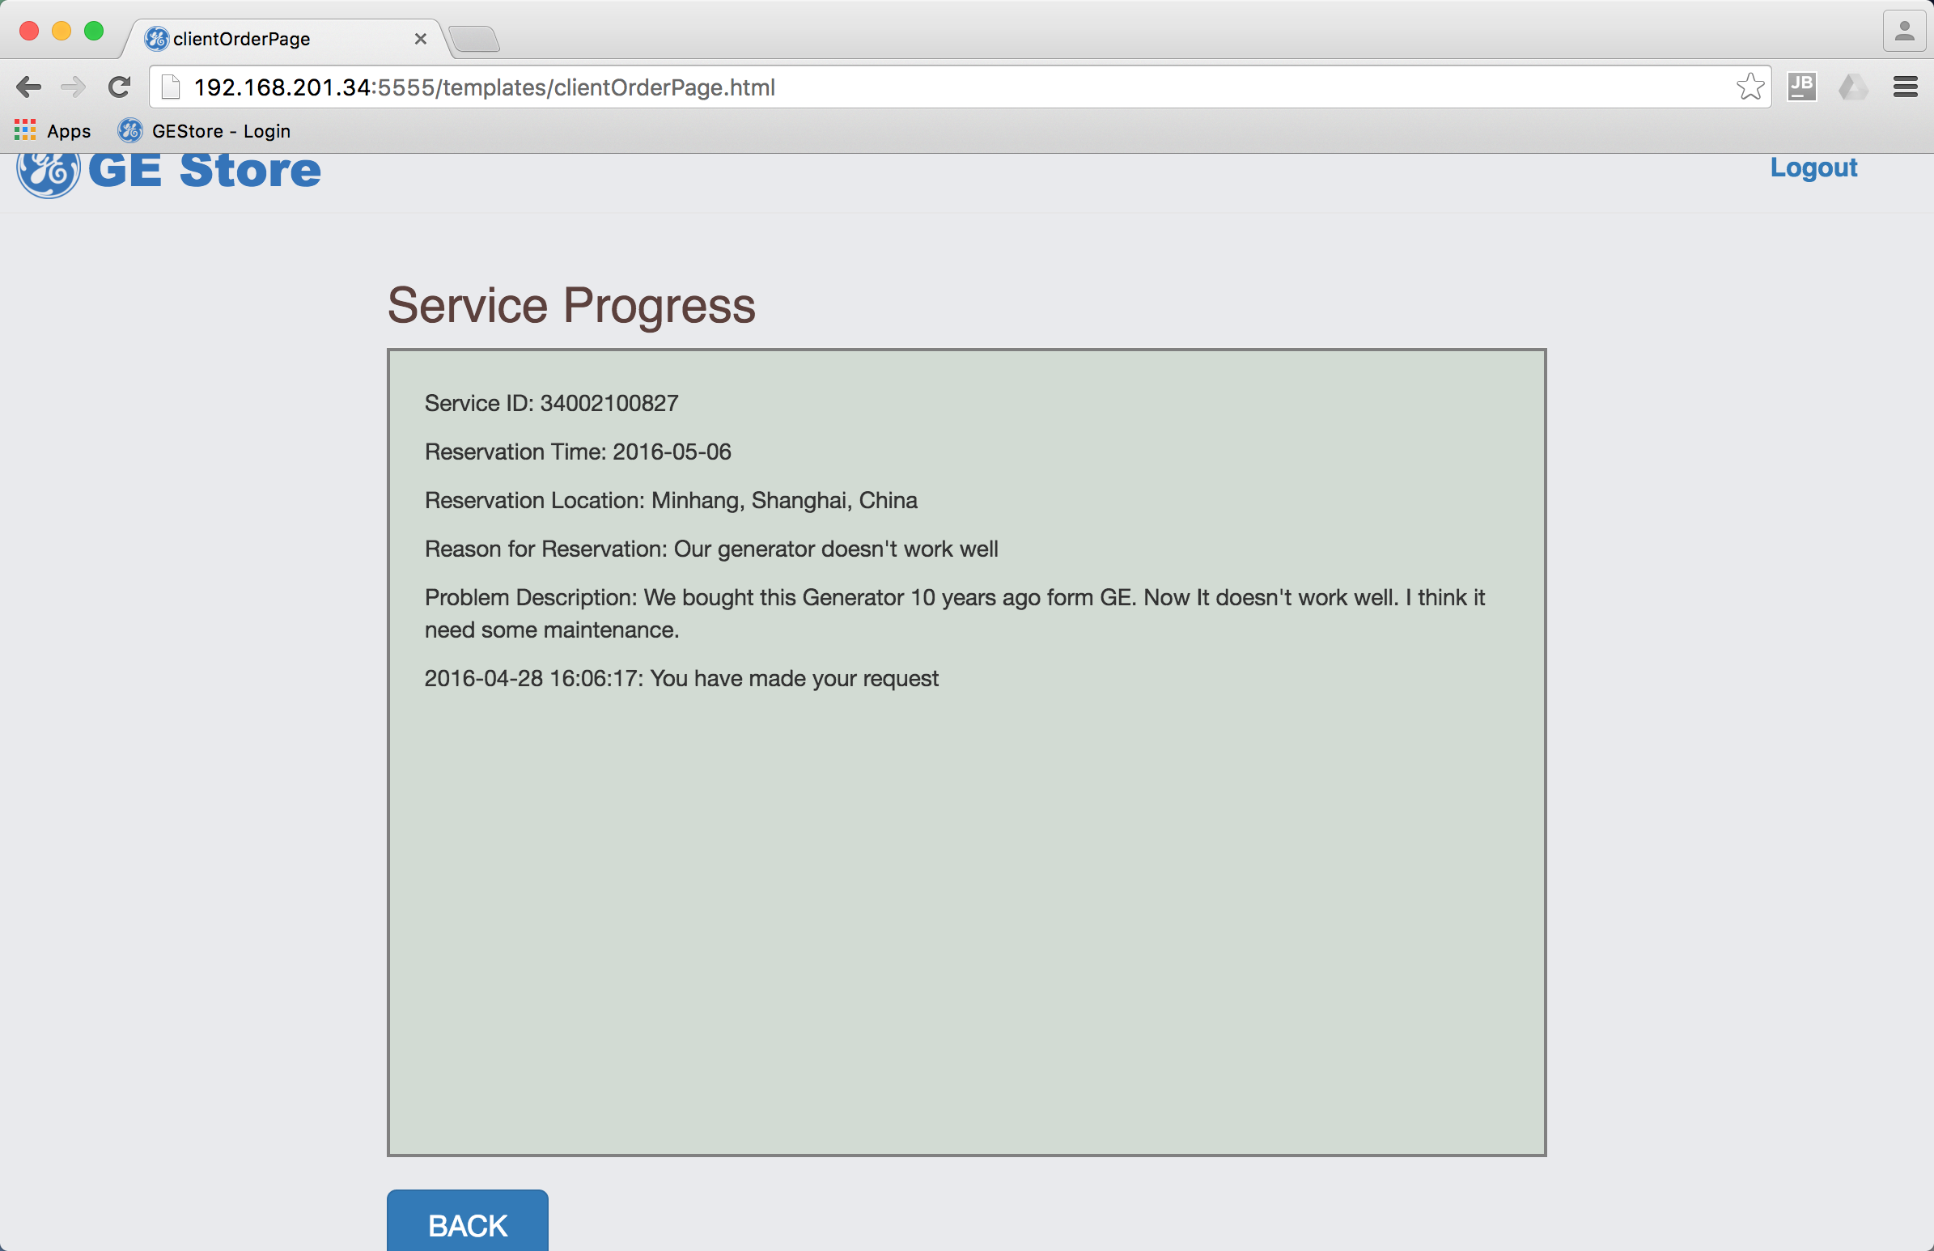 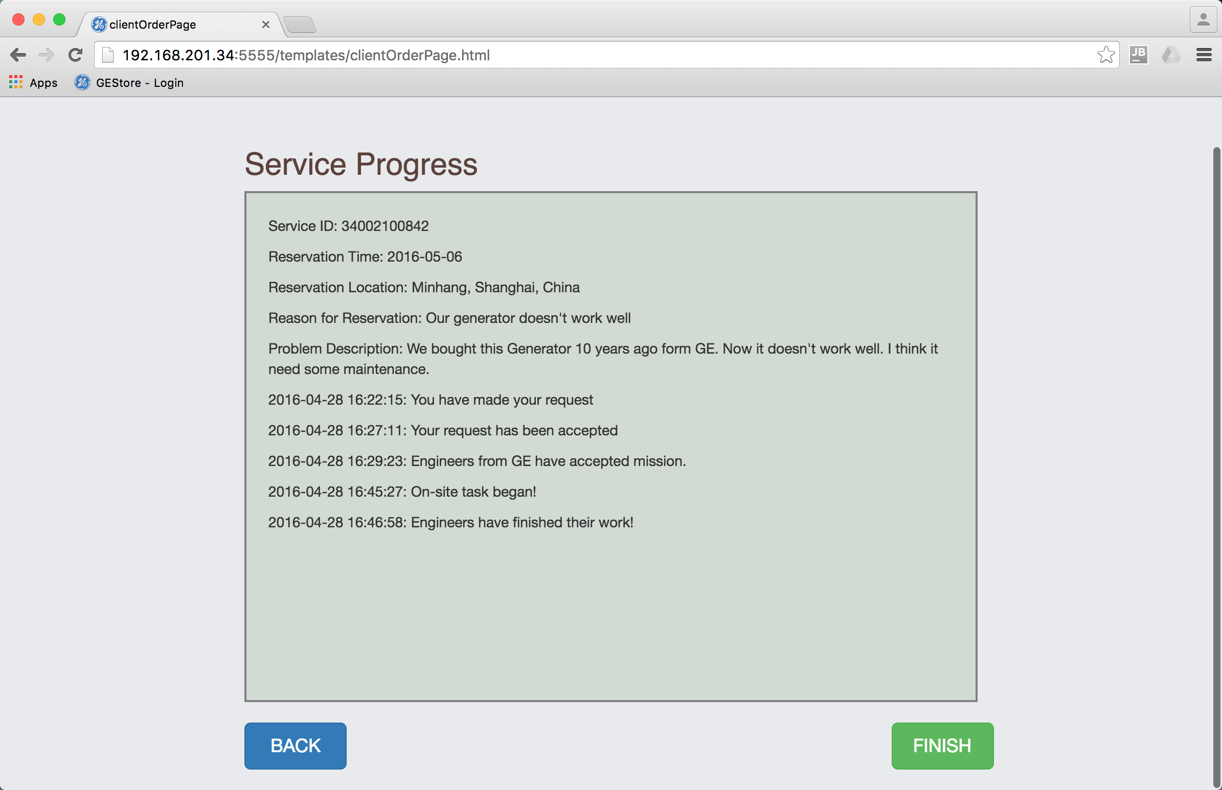

## 4.2 Interface for manager

The manager can check the whole processes of all requests sent by various clients. He/She is also in charge of the database, including checking all information of on-site processes, which are recorded by tool keeper manually in present implementation, and revising data. In addition, there are many advanced functions for the manager to improve work efficiency.[2]

1. Login from the same page with a manager account.

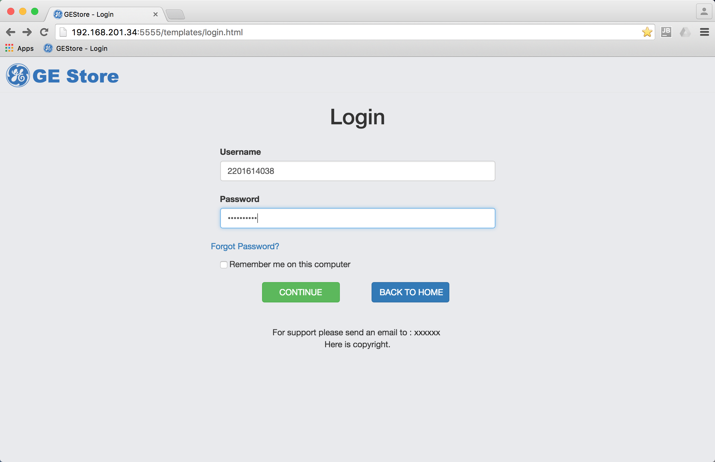

1. The page jumps to the personal center of the manager, personal information loaded automatically. Click “show current requests” to see all requests sent by clients.

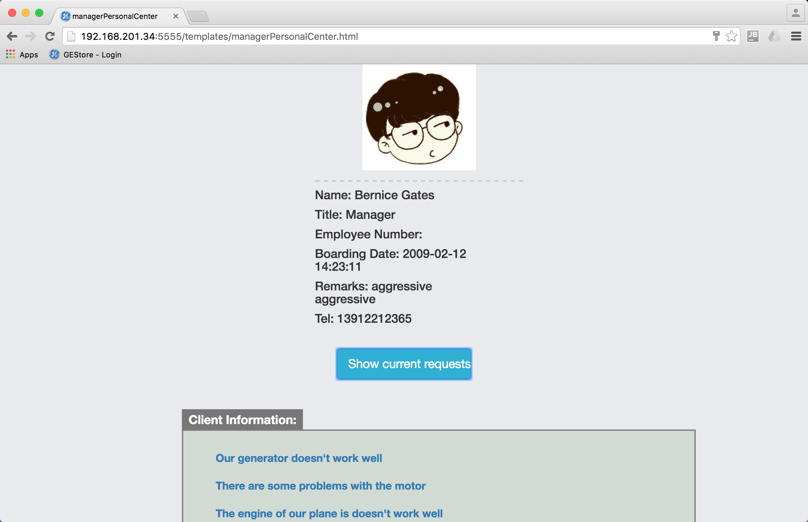

1. In the following page, all information of current requests is shown. After the client has made the request, a button “ACCEPT” will appear for him/her to accept this request[3]. At the end of the whole process, when the client has confirmed the completion of the service, another button “FINISH” will appear for the manager to confirm completion of the process.

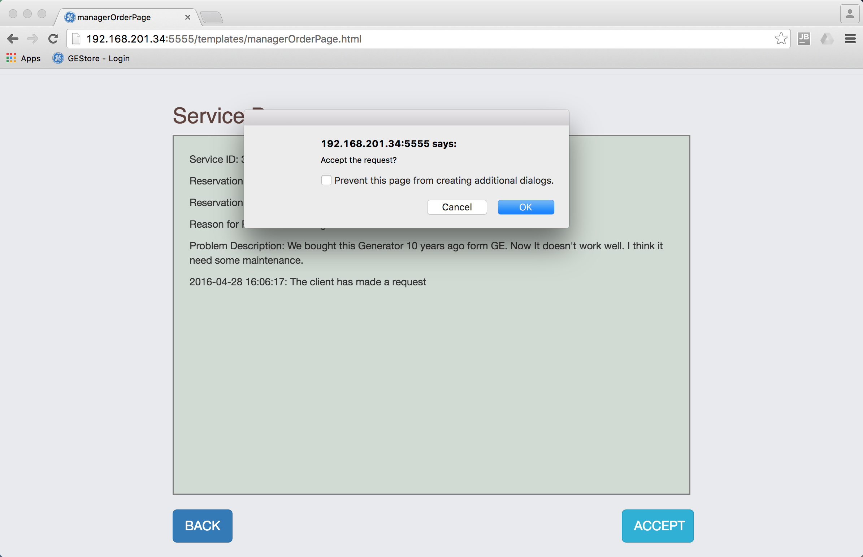 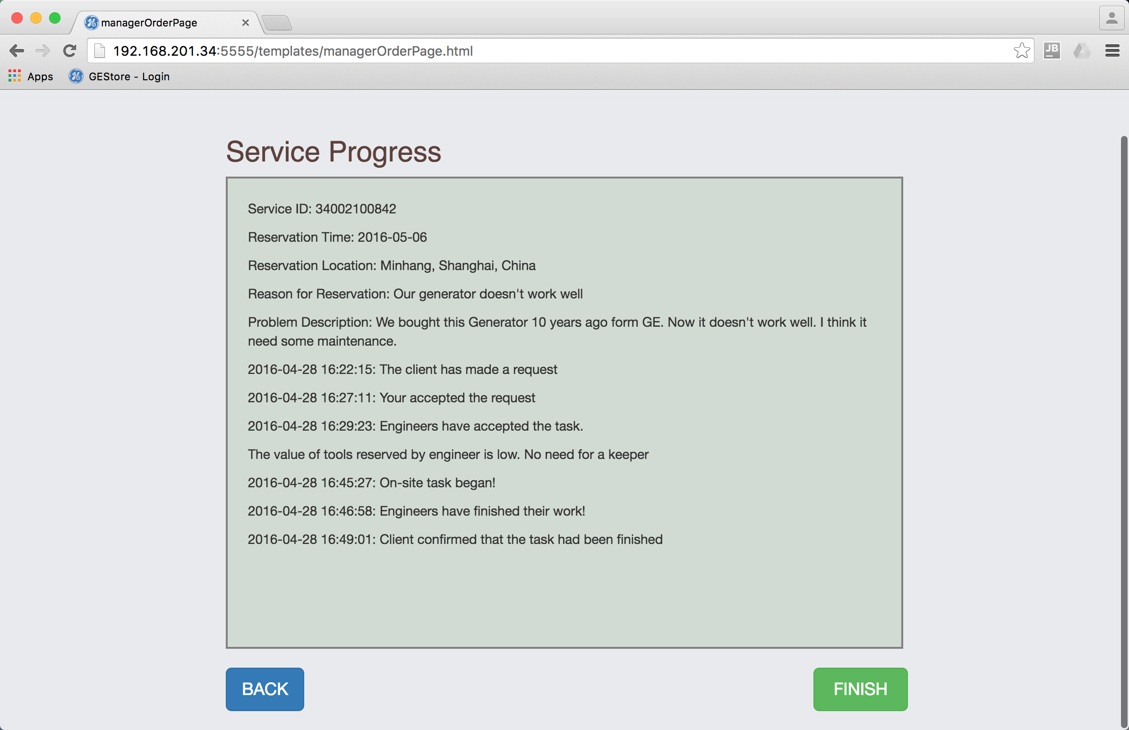

1. After on-site task has began, a button “Check Onsite Operating Information(EXCEL) will appear for the manager to download all the on-site information of current service as an EXCEL at any time. This button will not disappear once it appears.(Due to some unknown problems, currently this can only be implemented in local computer.)

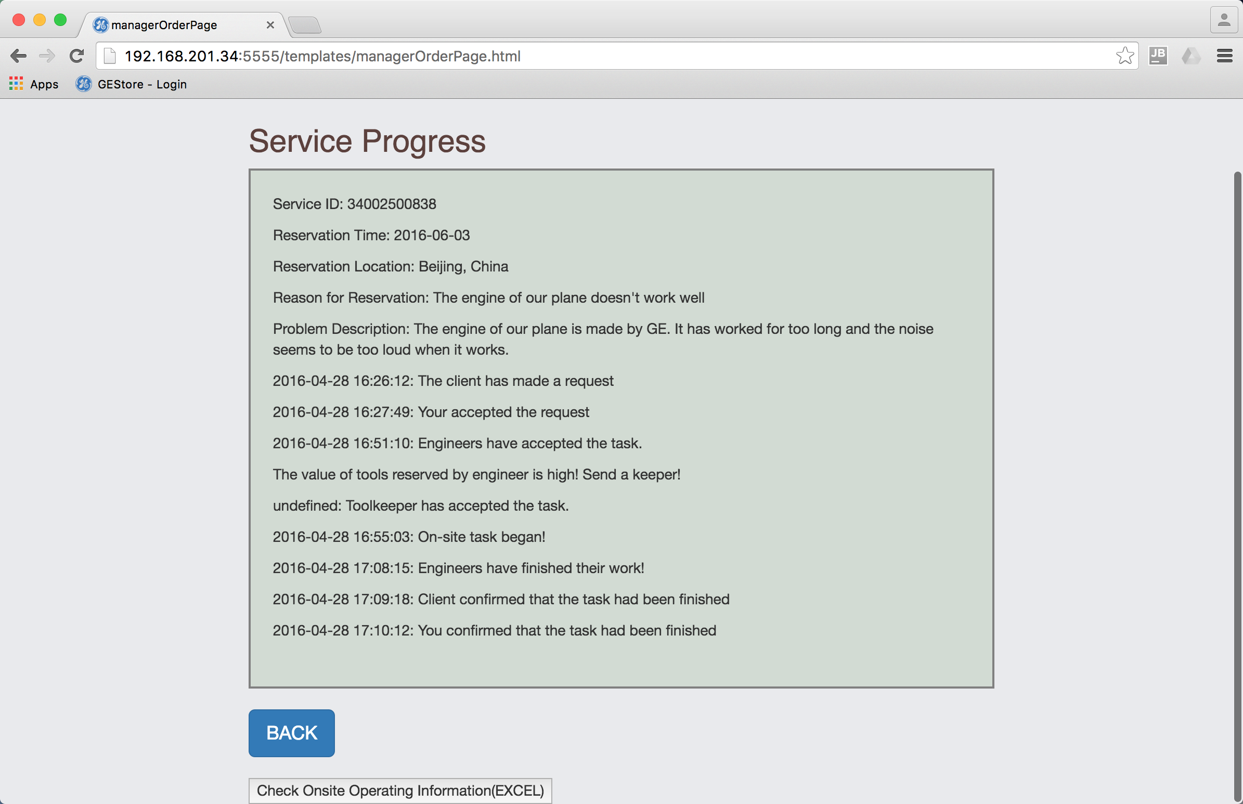

## 4.3 Interface for engineer

An engineer can accept tasks, make a reservation for tools, return tools and update tool status online if he is responsible for the tools.

1. Login from the same page with an engineer account.

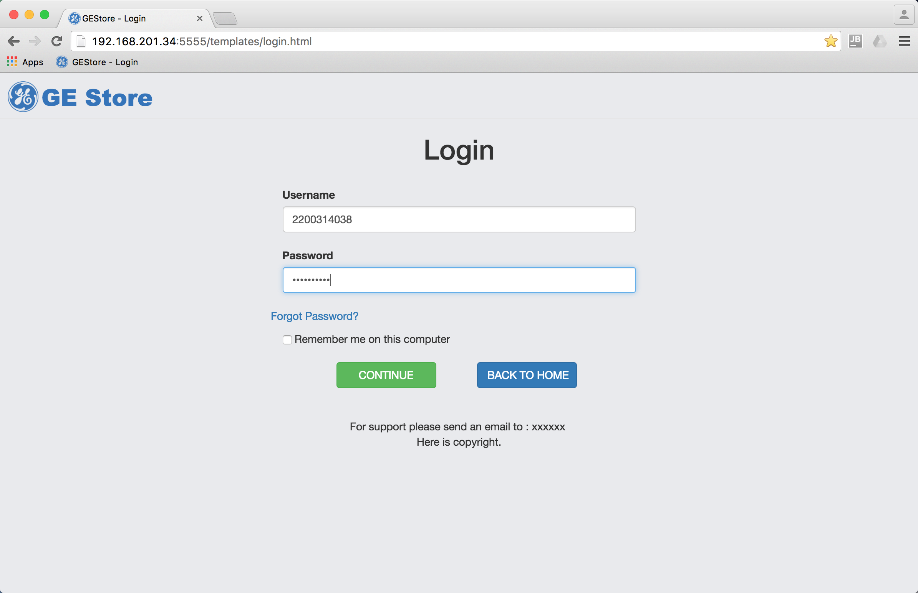

1. Click “show current requests” and choose the request he want to accept. The engineer can see requests he has accepted or those haven’t accepted by other engineers.

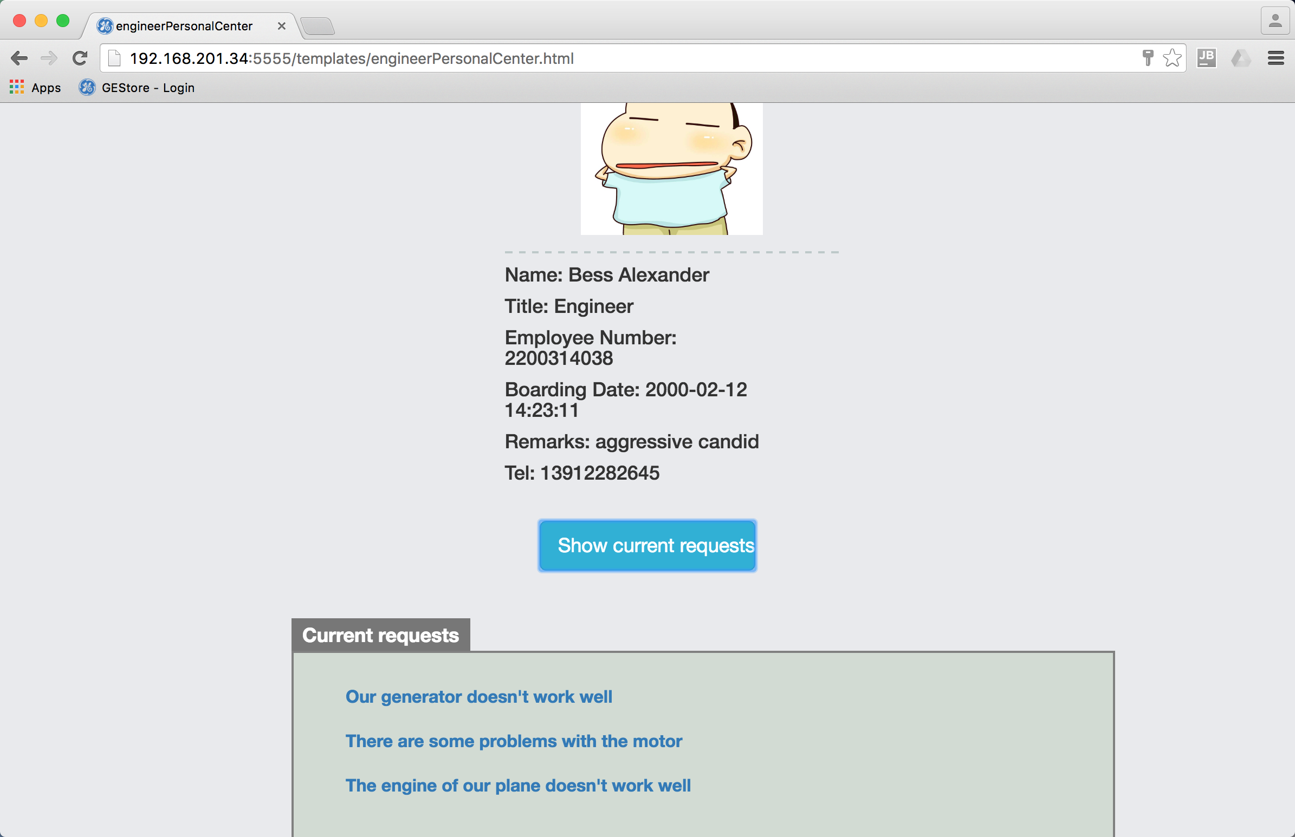 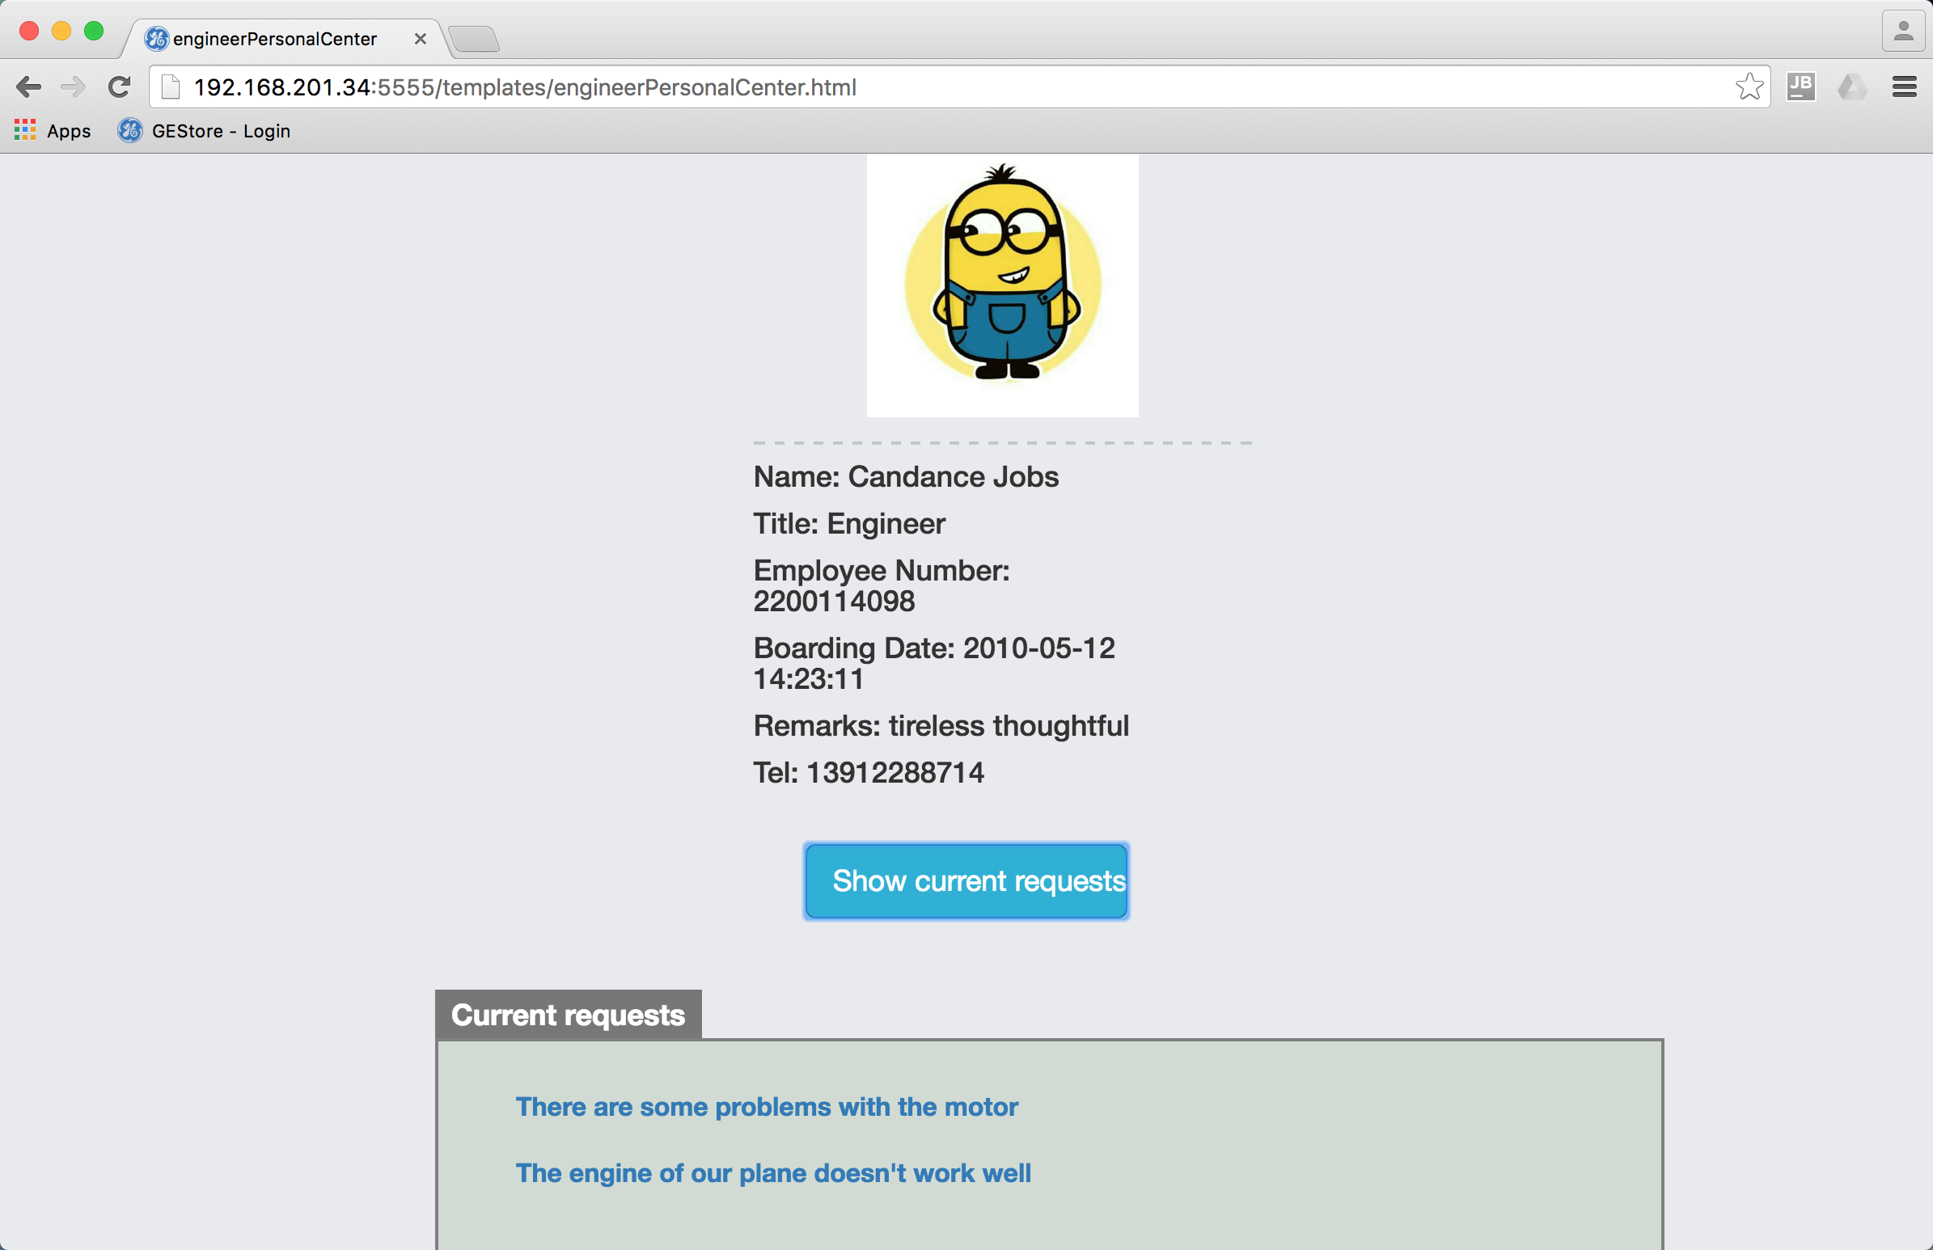

1. After the manager has accepted the request, the engineer can see the button “ACCEPT” on the following page. And the button “Reserve Tools” will appear after he has accepted the request. Click this button to make a reservation for tools he need.

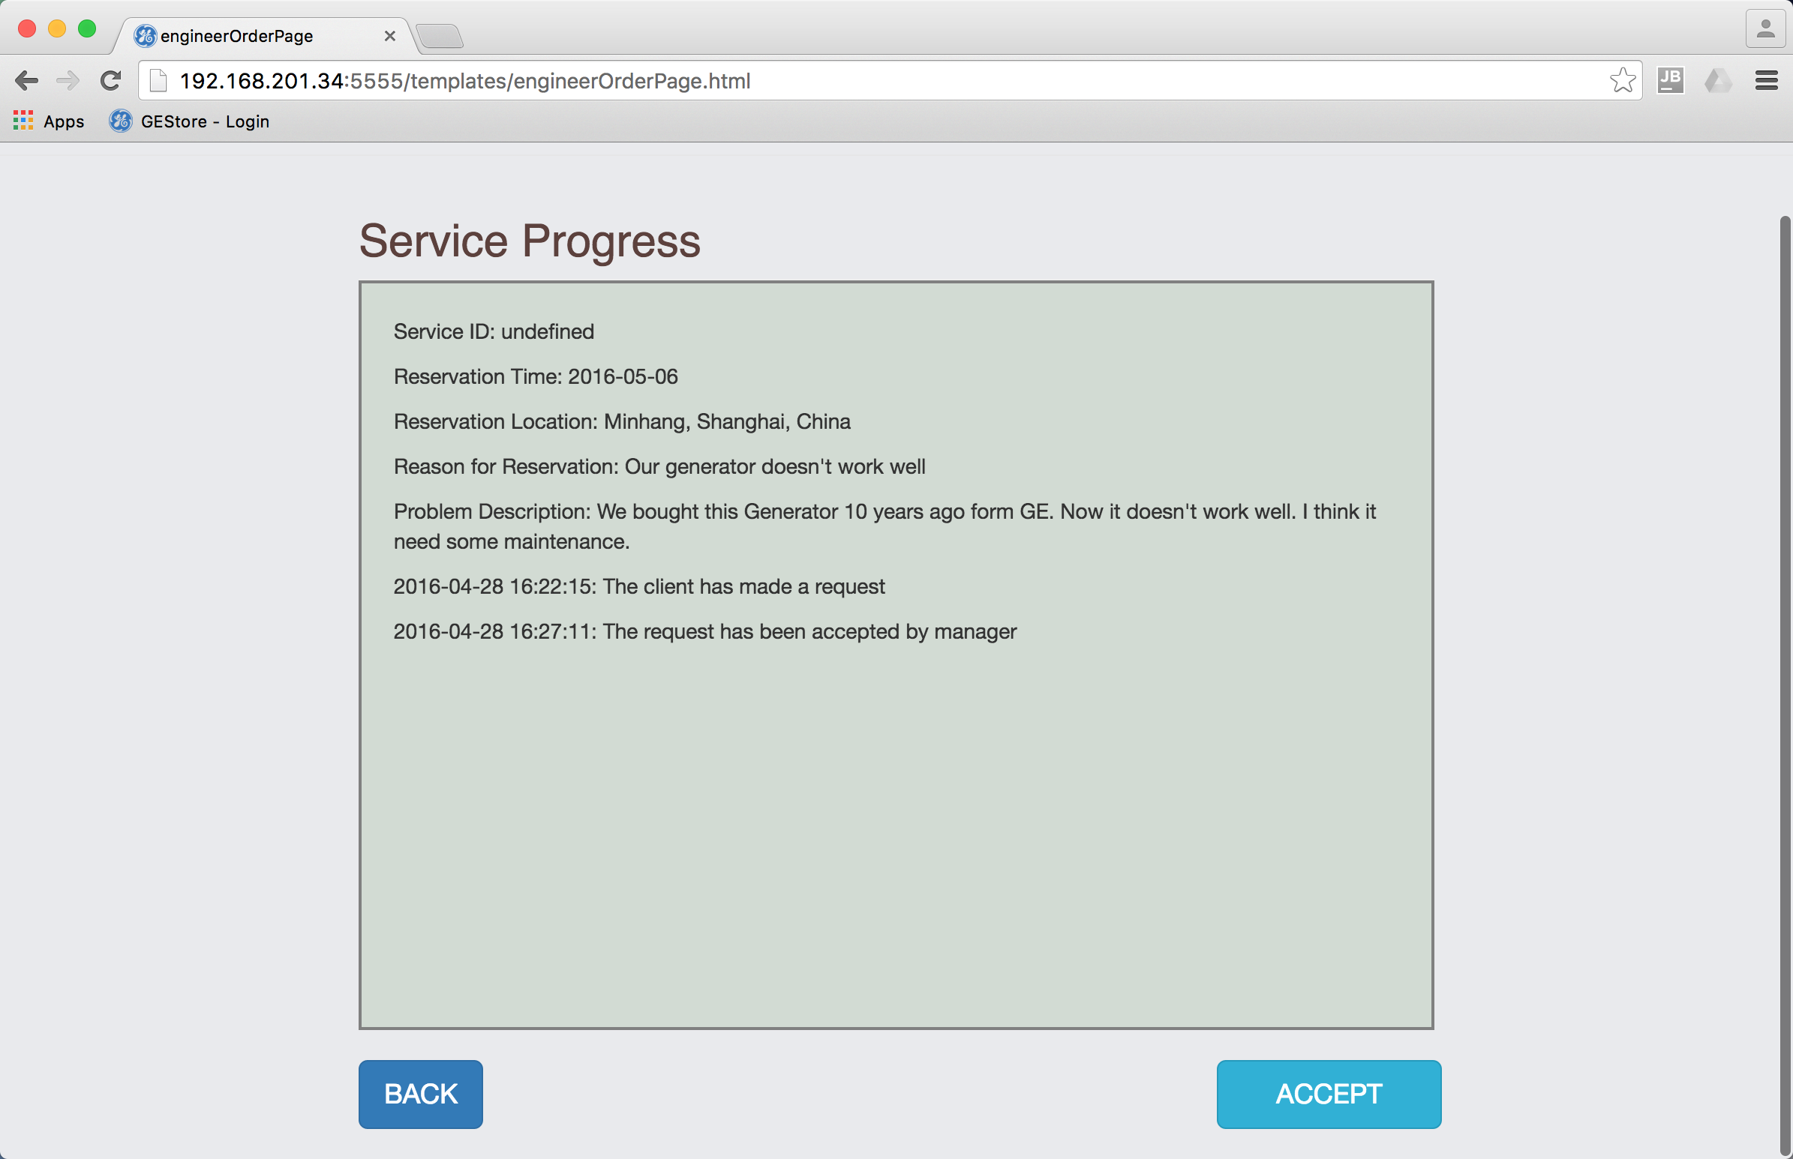 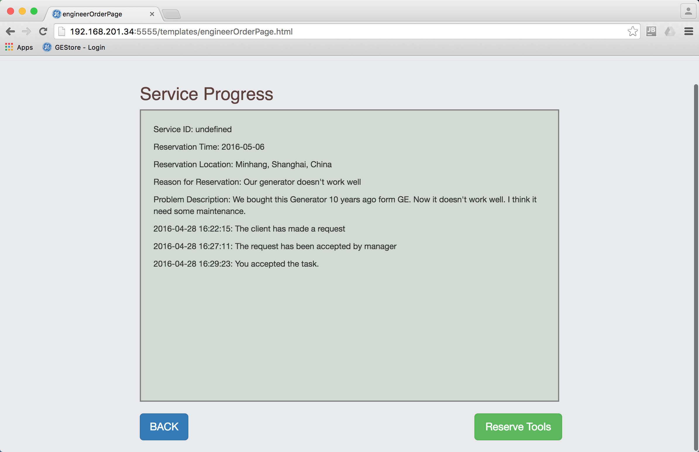

1. Put in an ID or a name and click “SEARCH”. All possible results will be shown below. Click one of them and a dropdown box appears.

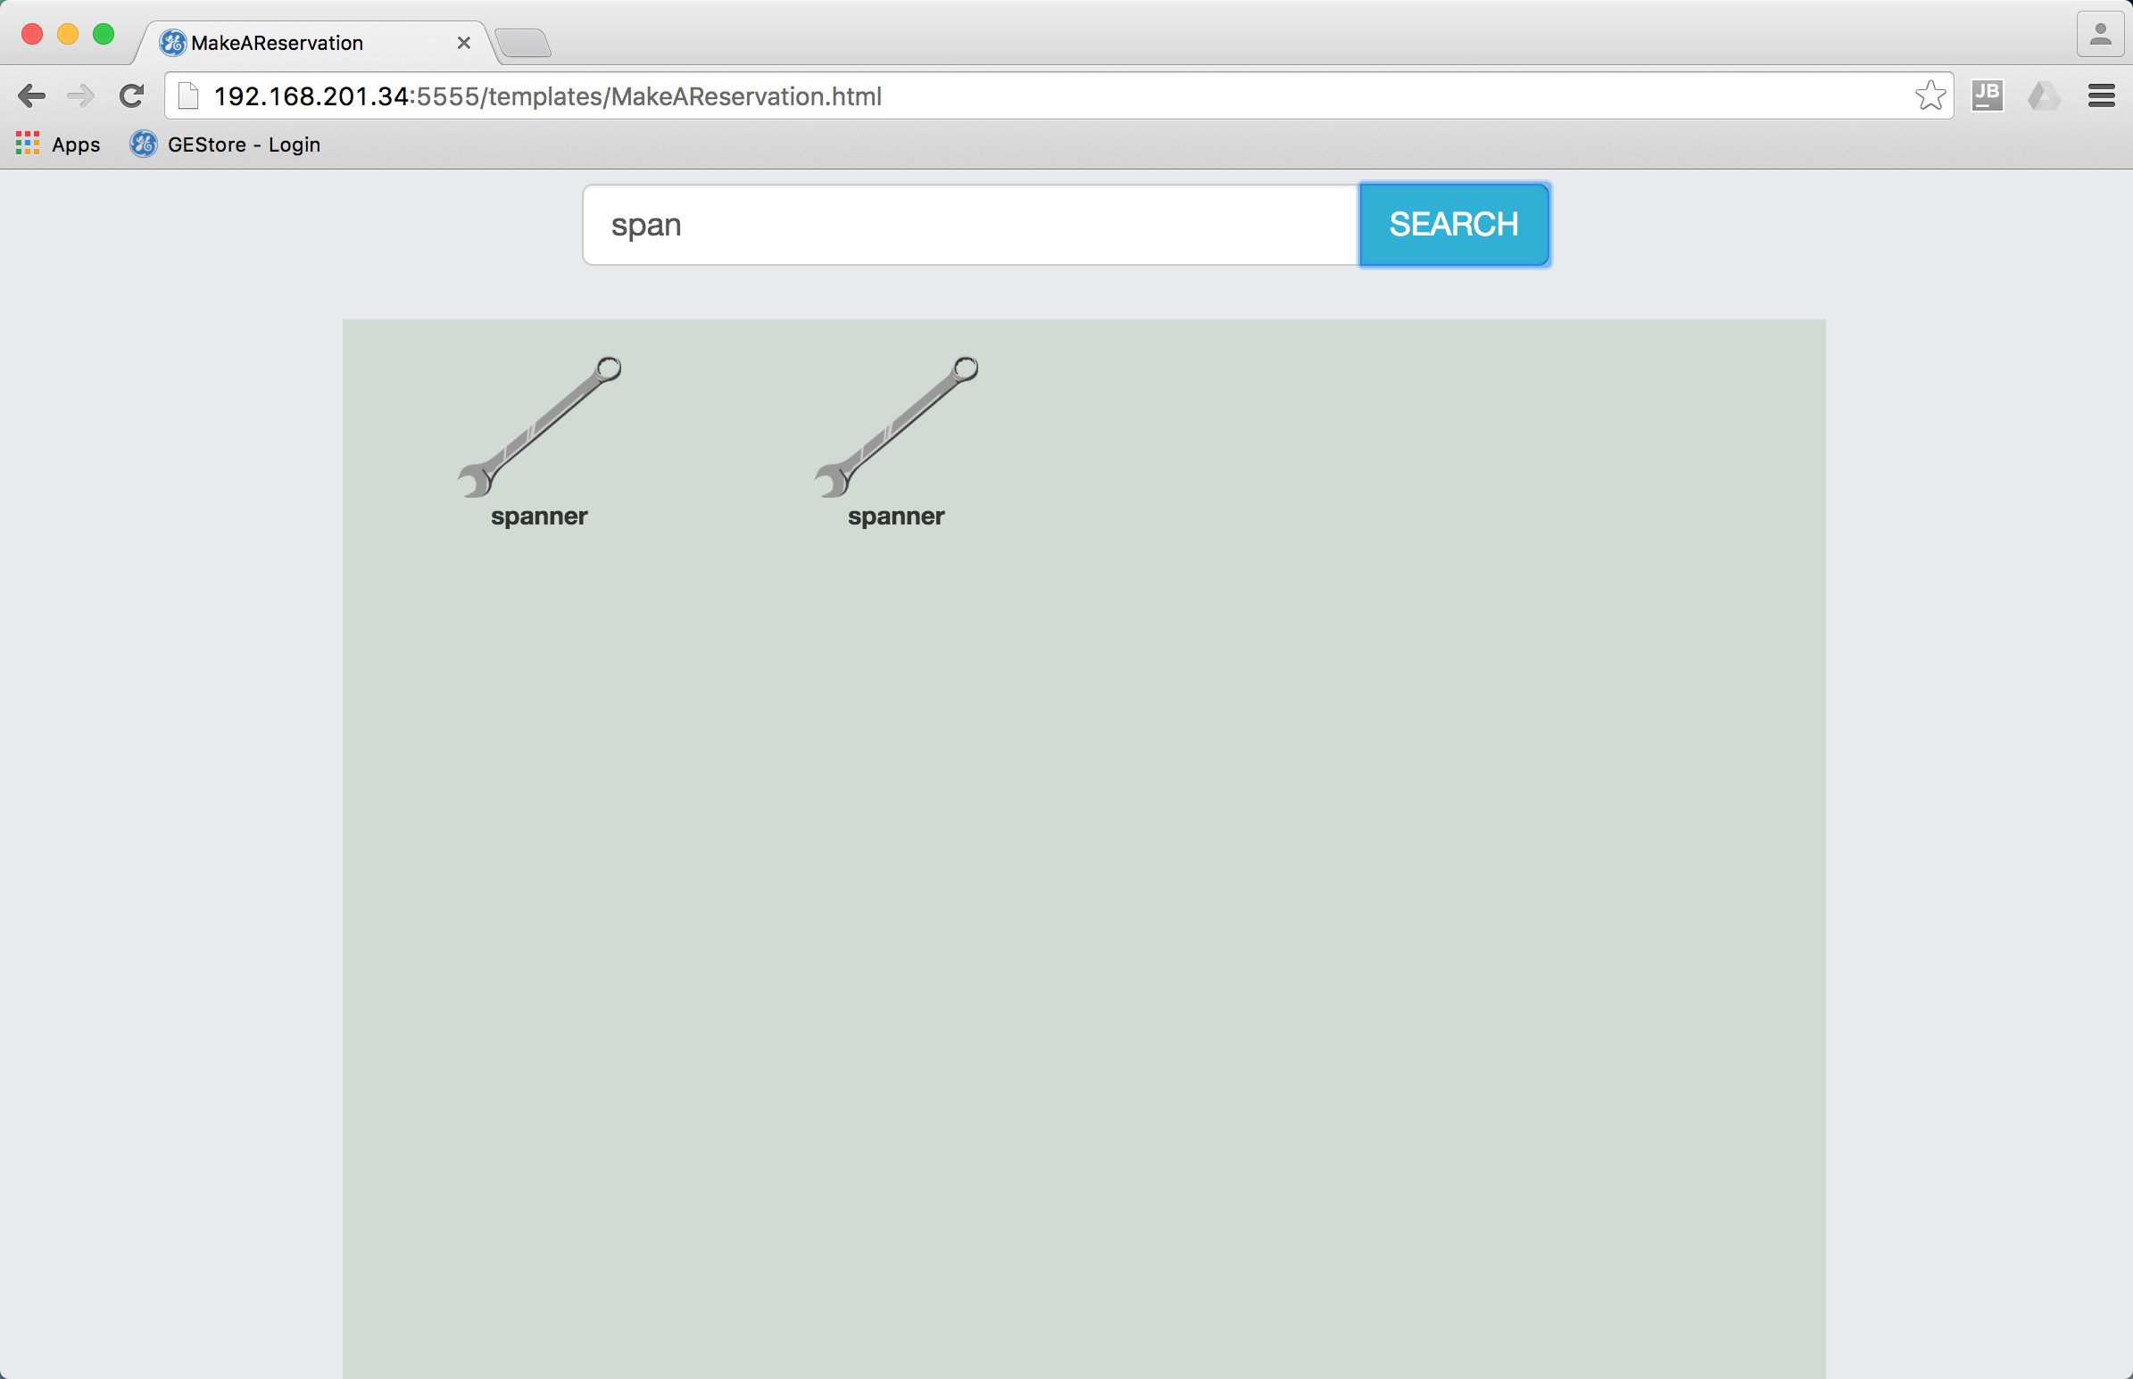 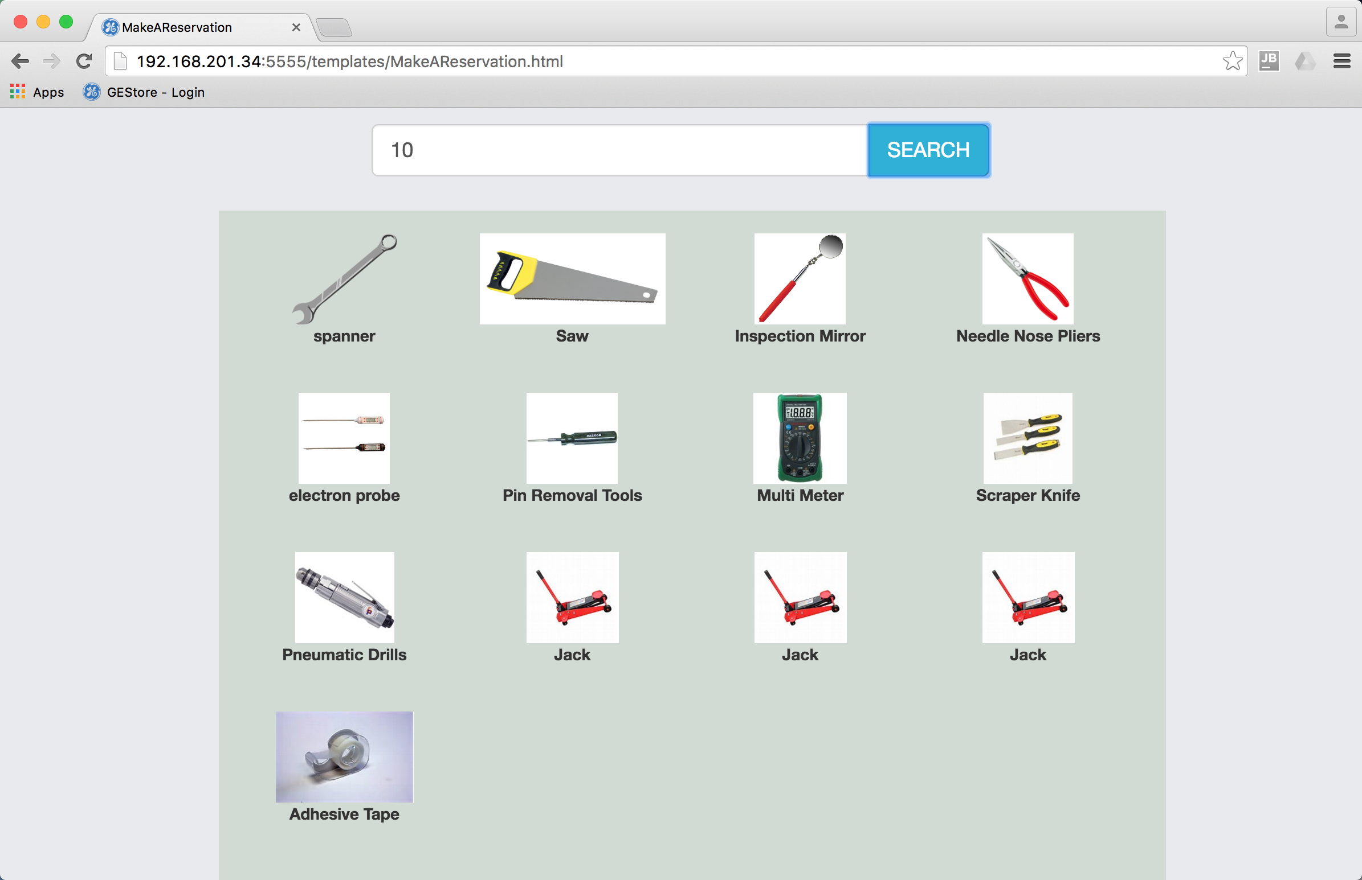

1. If this is the tool wanted, click “SUBMIT” to borrow the tool. Repeat (4) and (5) to get all tools in demand.

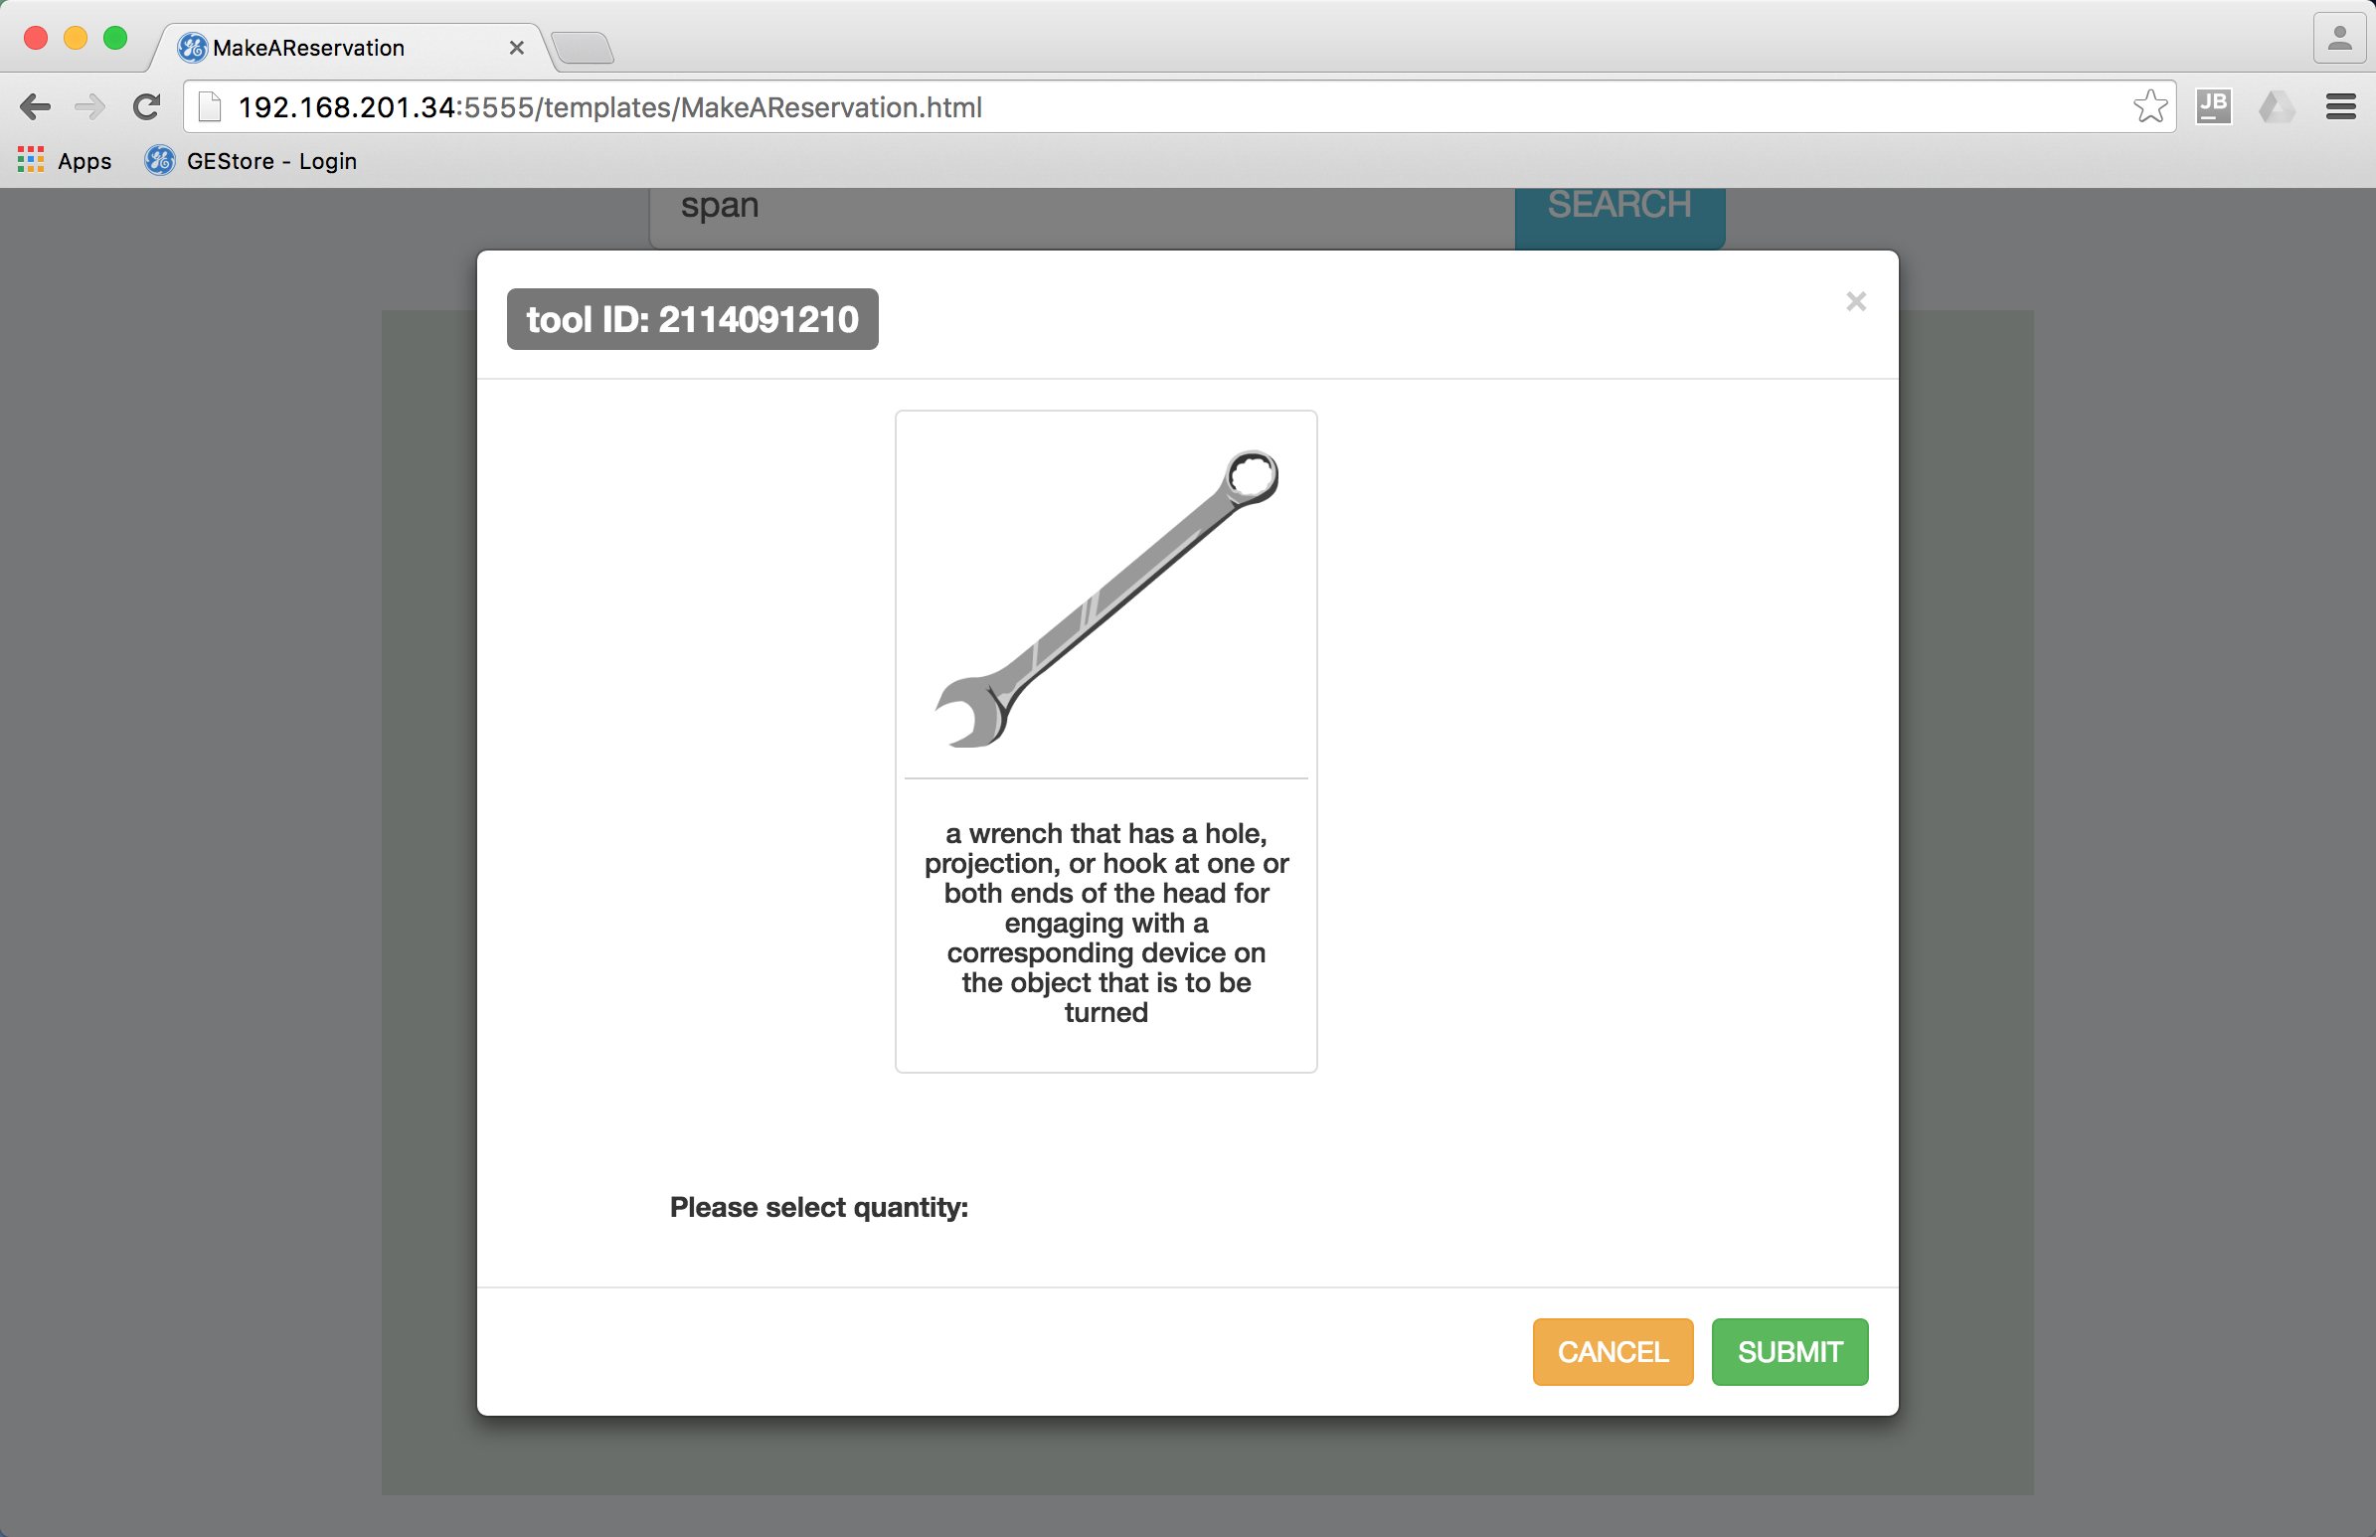

1. Enter the predicted time for returning the tool at the bottom of the page and click “CONTINUE”.

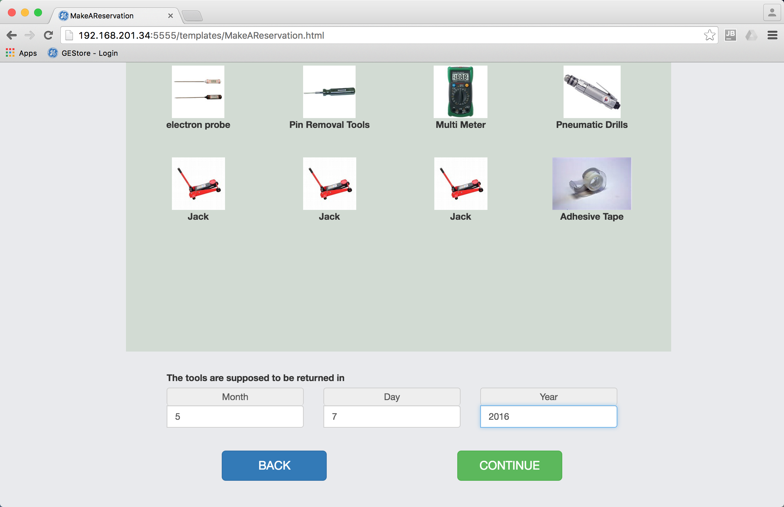

1. The Engineer who made the reservation of the tools is responsible for this whole task. In the follow page he can enter the engineers he wants to work together in this task. Search for other engineers the same way you search for tools. Click “FINISH”.

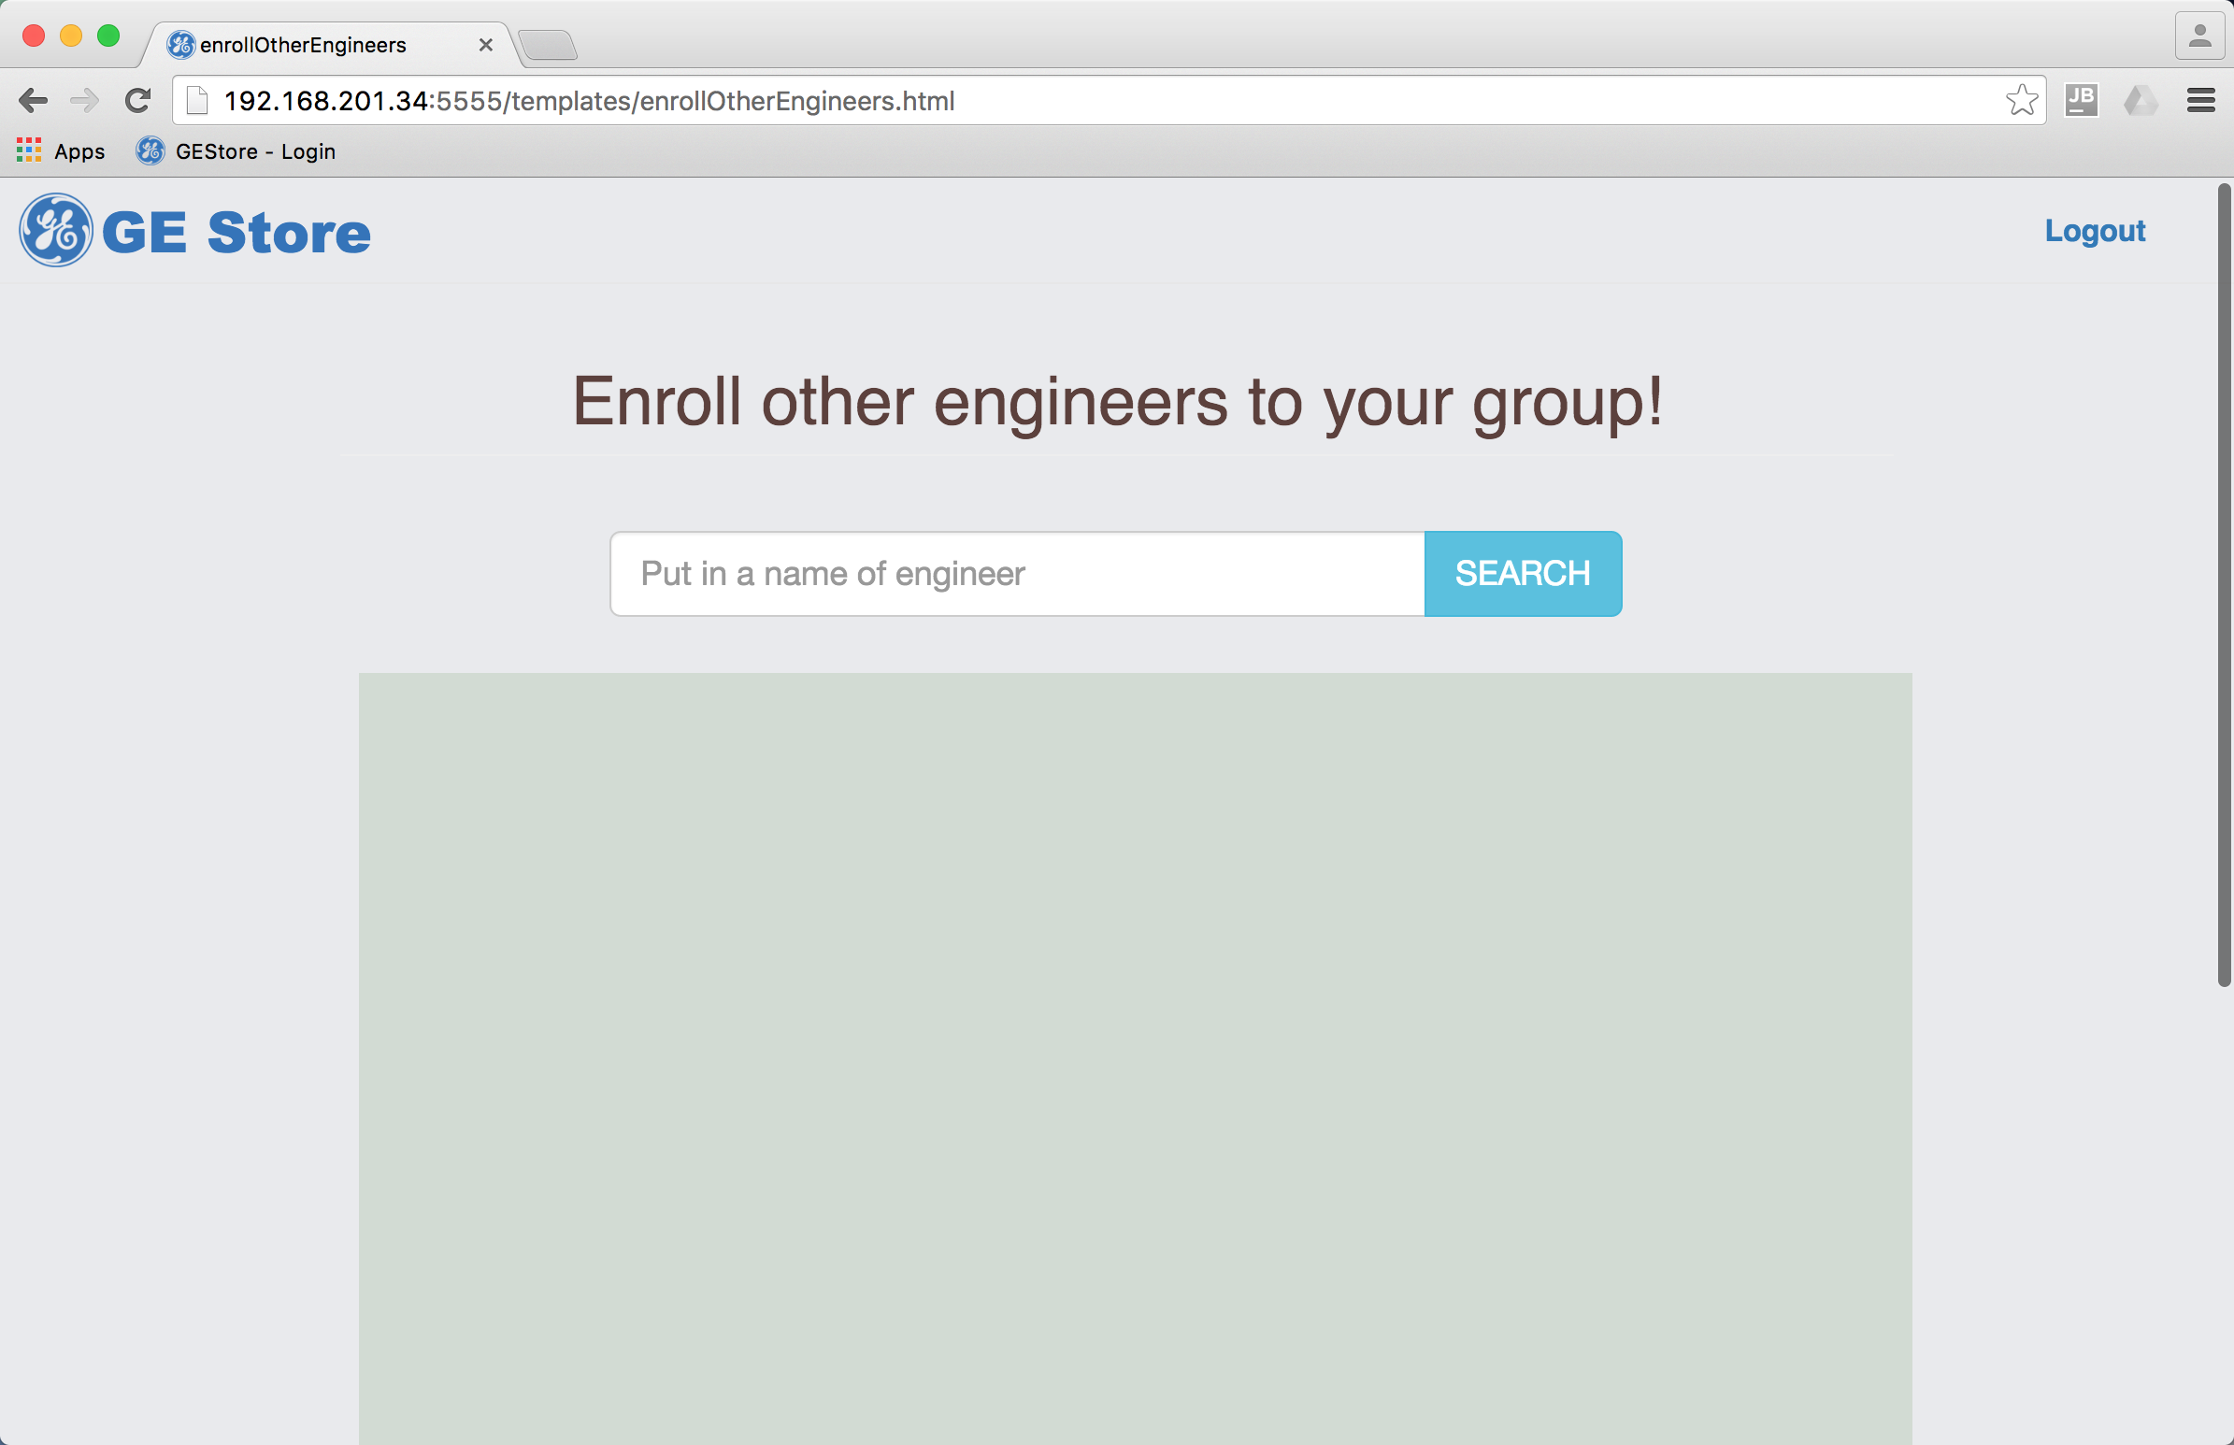 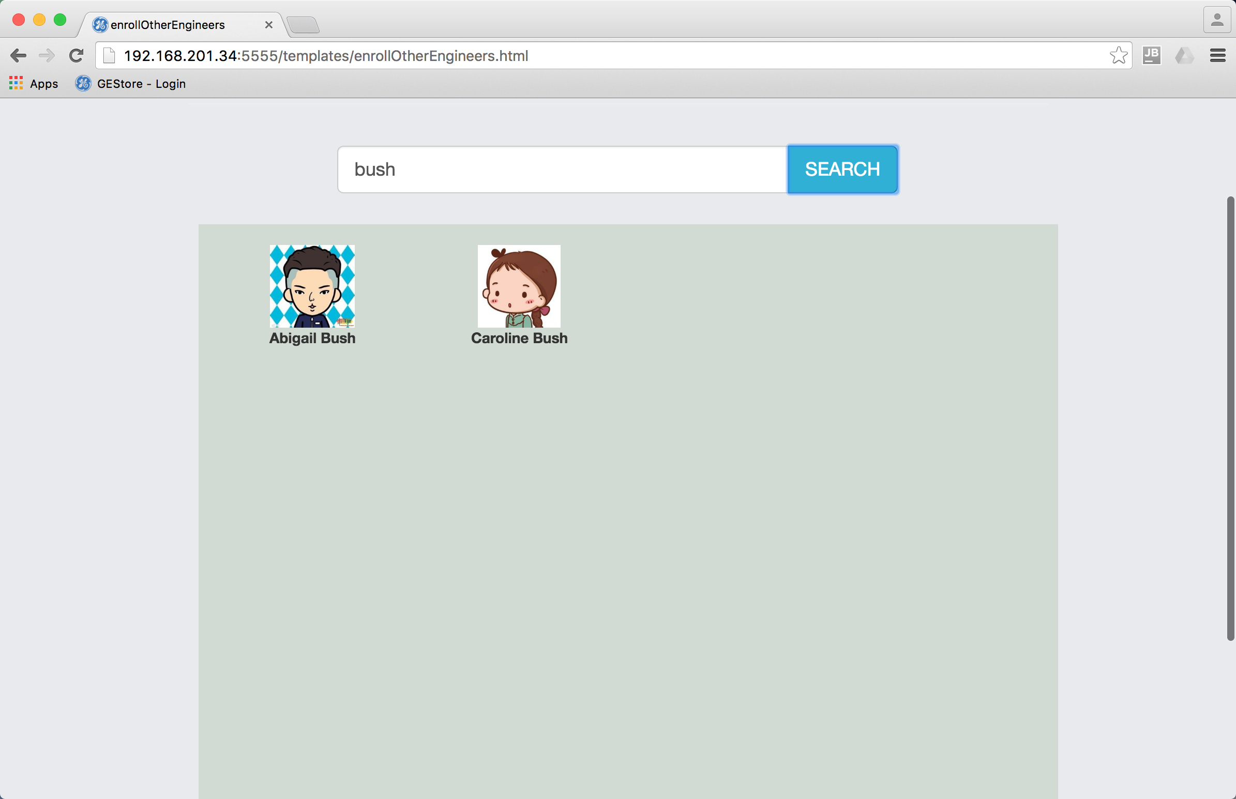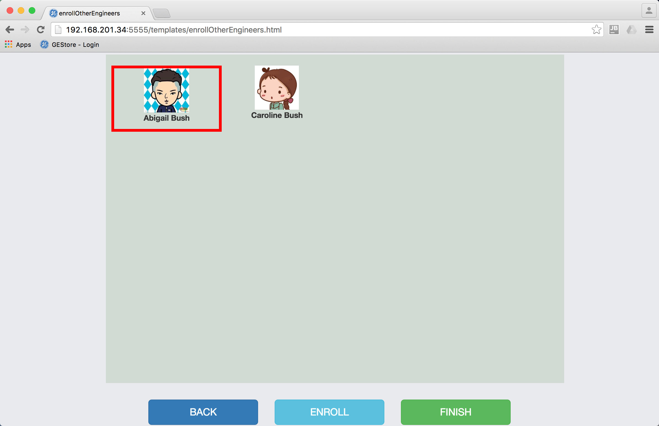 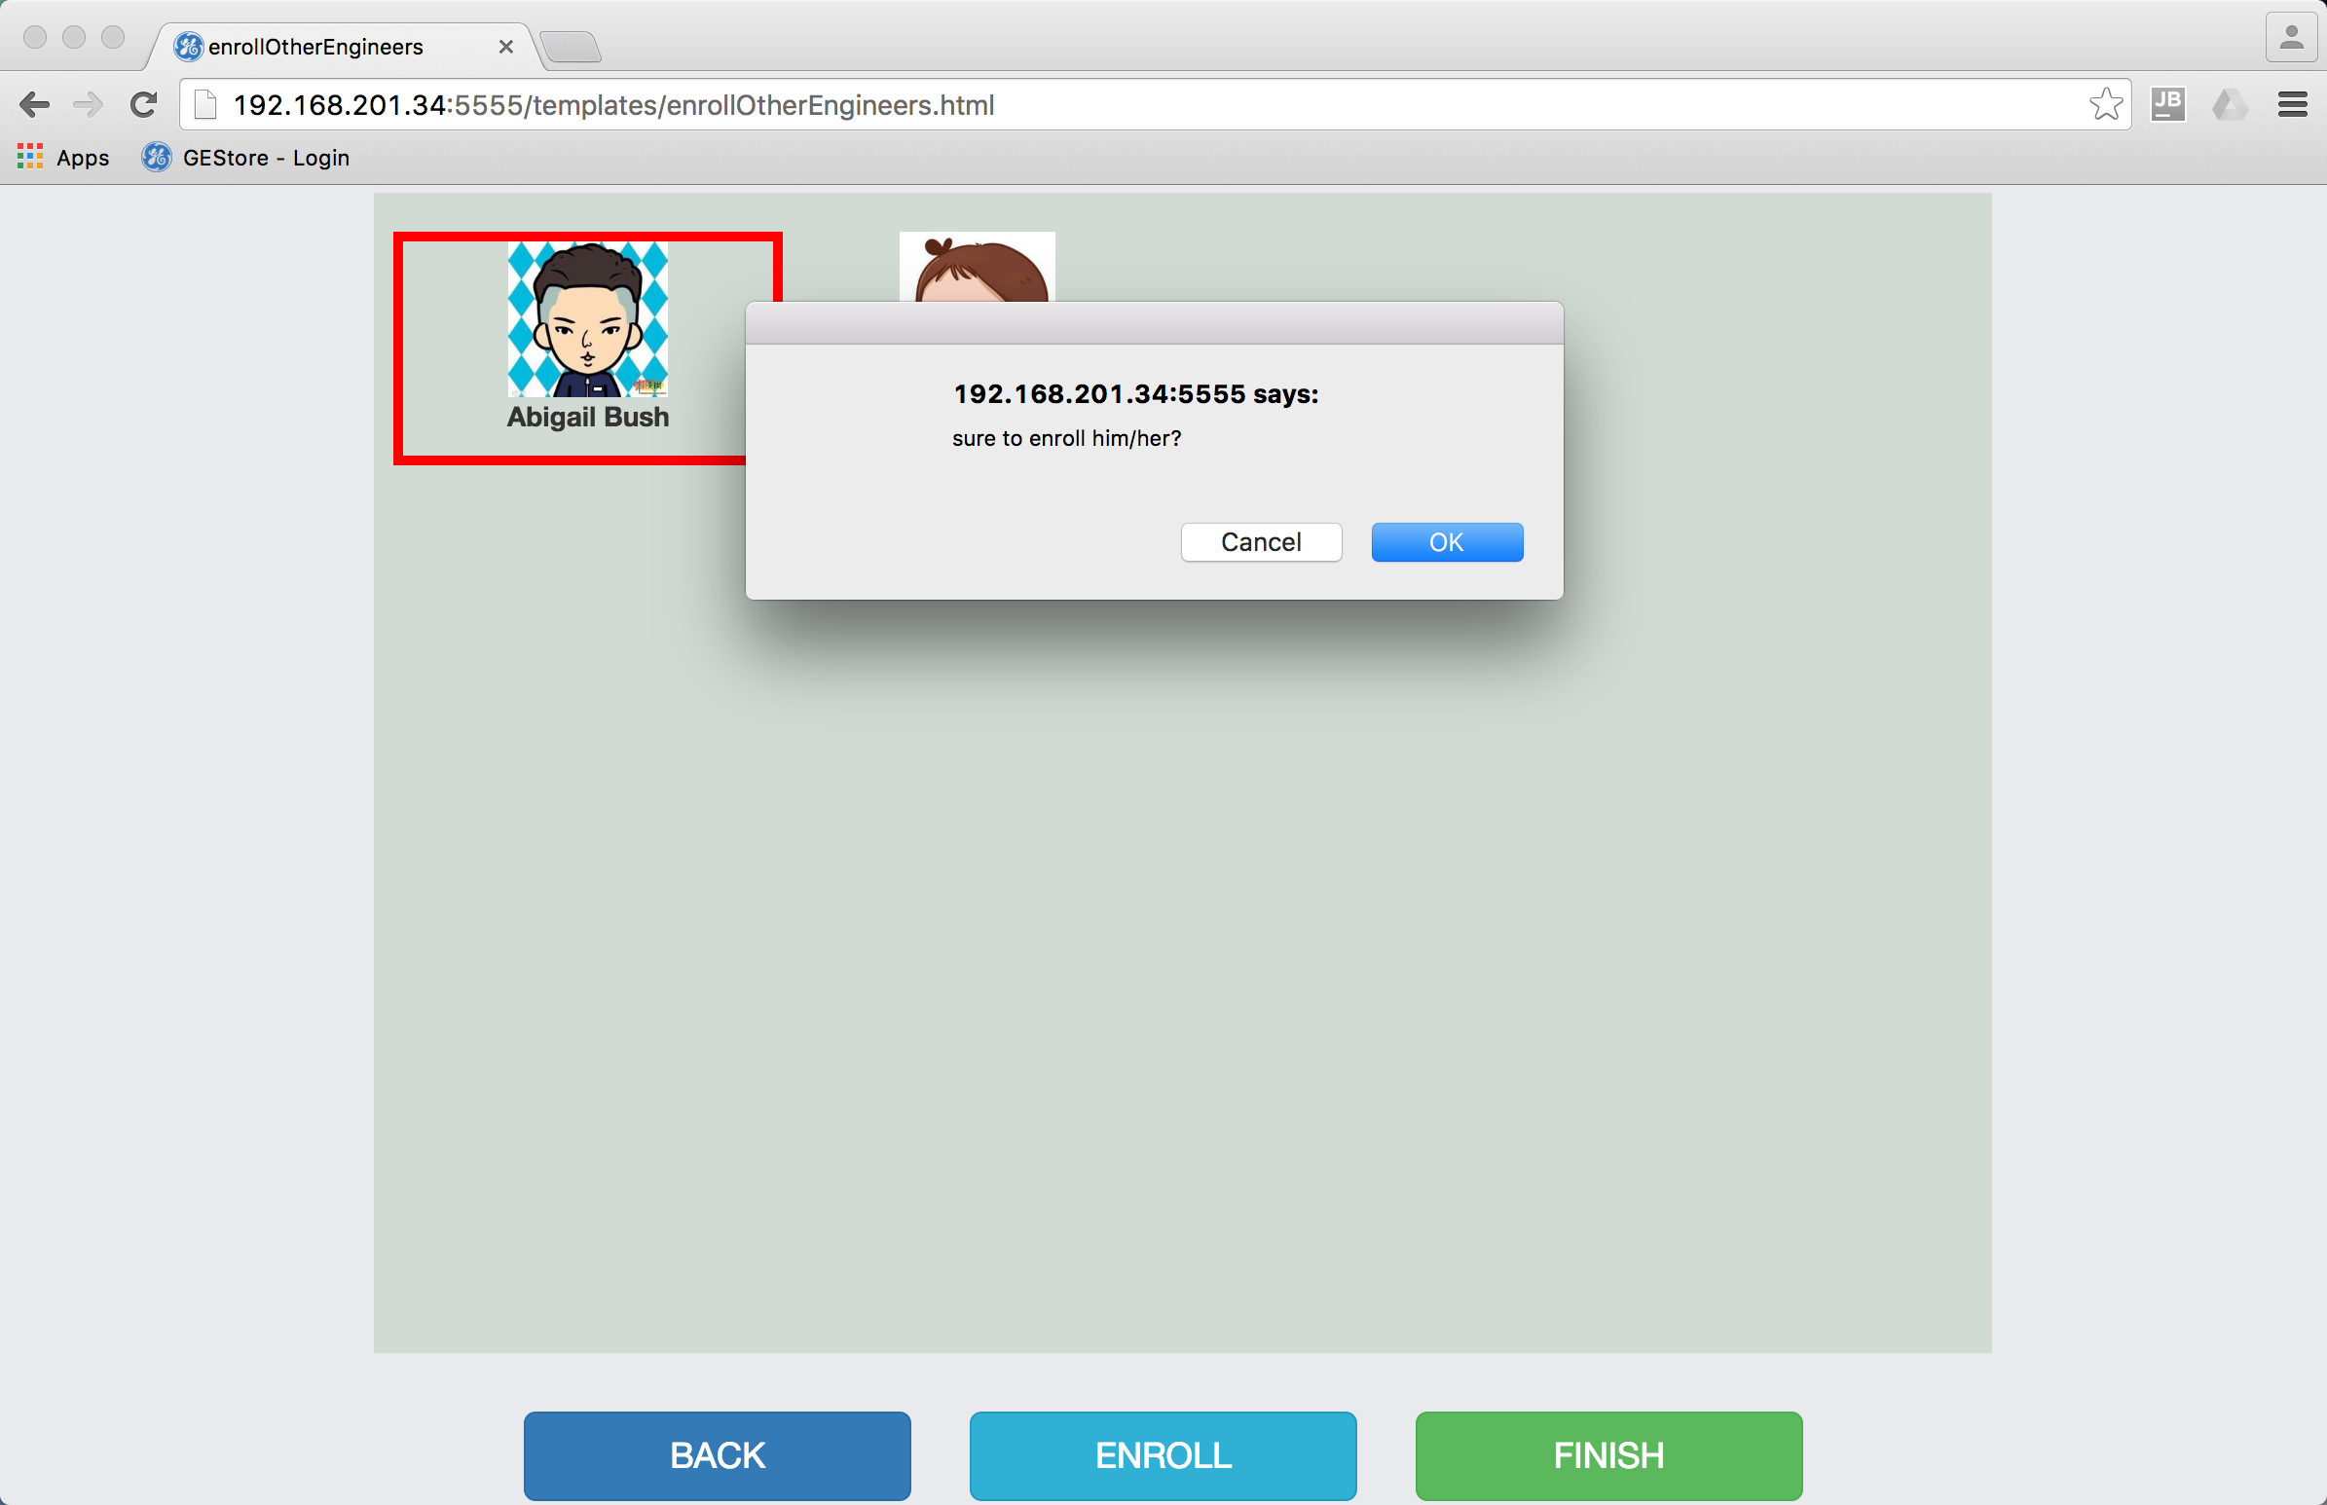

1. The server will automatically decide whether the value of tools is high or low[4]. If the value is high, the system will inform that the value is high, a tool keeper will go with the engineer and the tool center is responsible for the transportation of the toolbox. If the value is low, the system will inform that the value is low, no tool keeper will go, and the engineer can choose whether he needs express service. After the process is finished, the page will jump back to personal center[5].

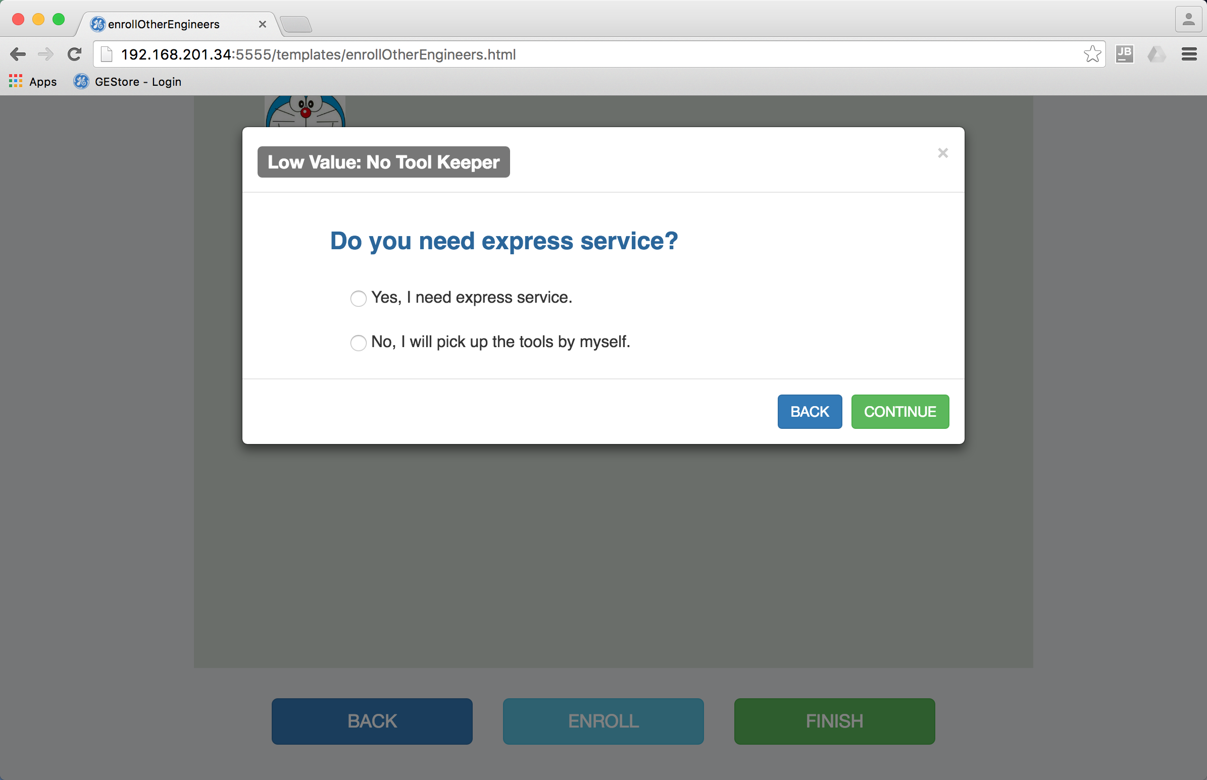 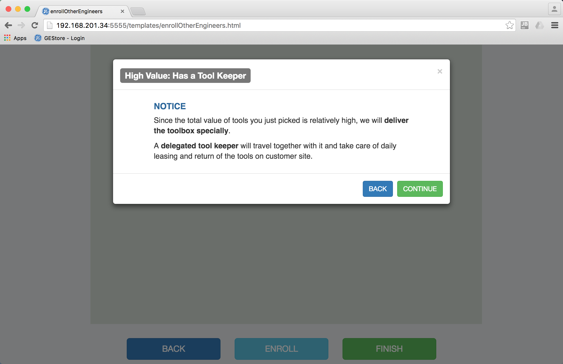

1. If the value is low, no tool keeper will go, and the engineer is responsible for the tools. In this situation, a button “Return Tools” will appear in personal center.

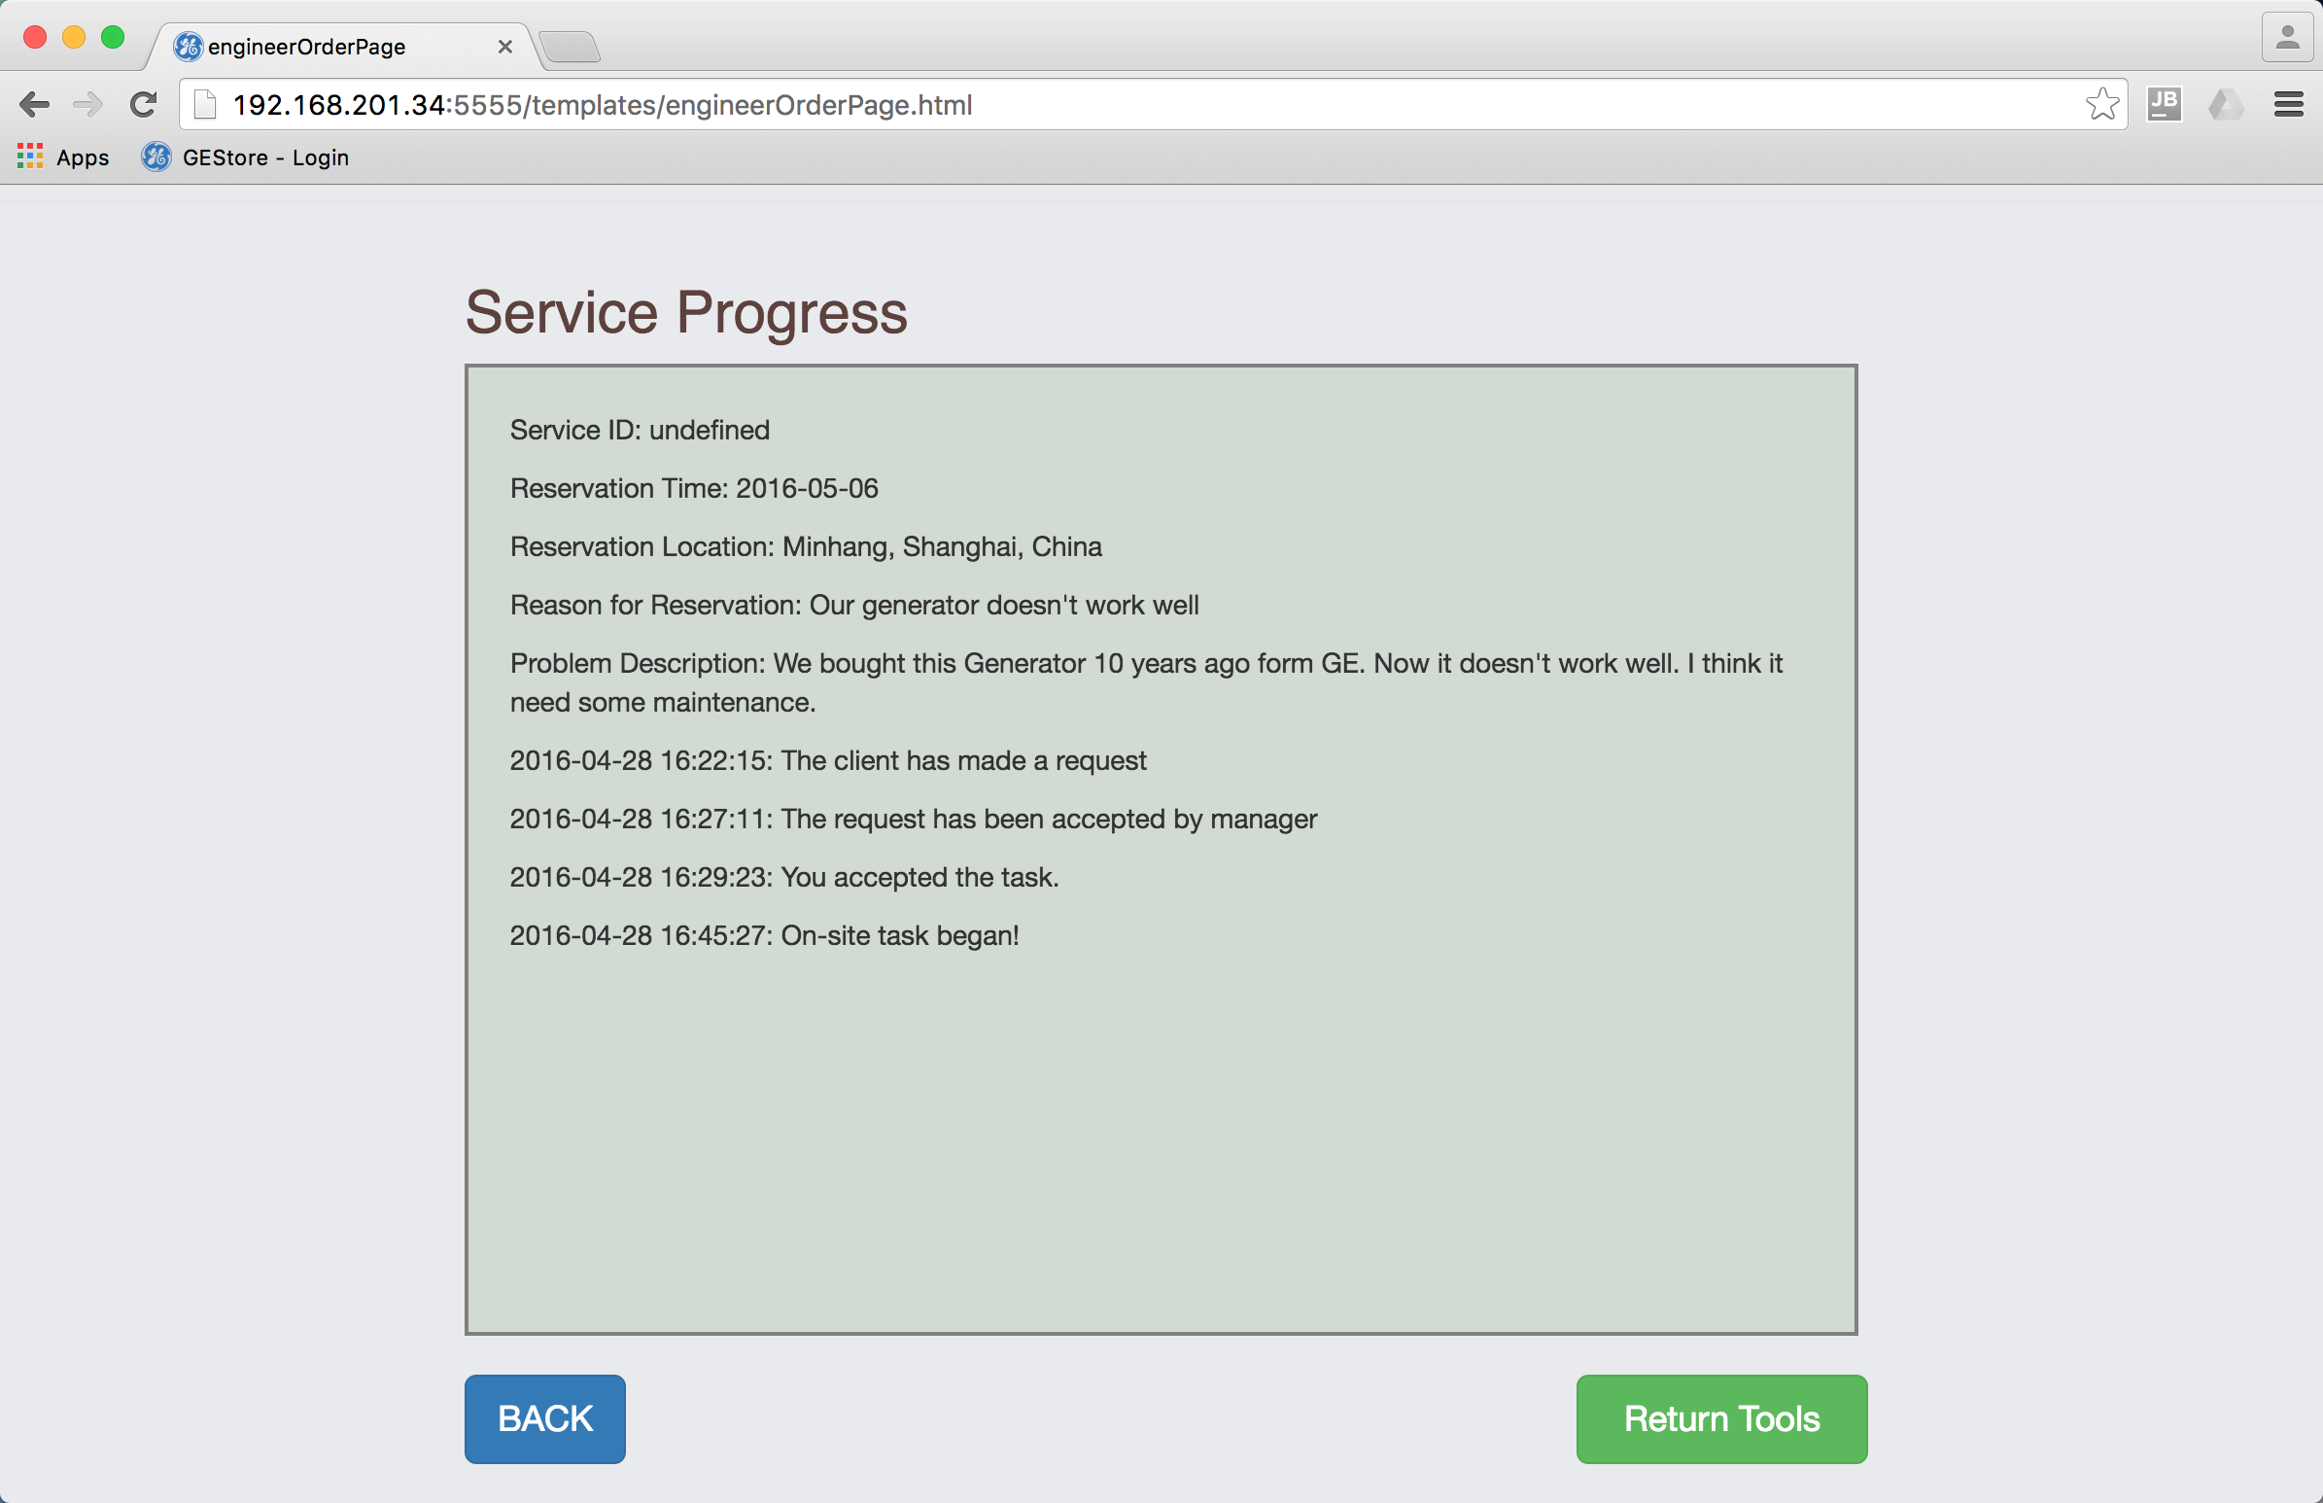

1. In the following page, all tools borrowed are shown. The engineer can choose one by one and update status[6].

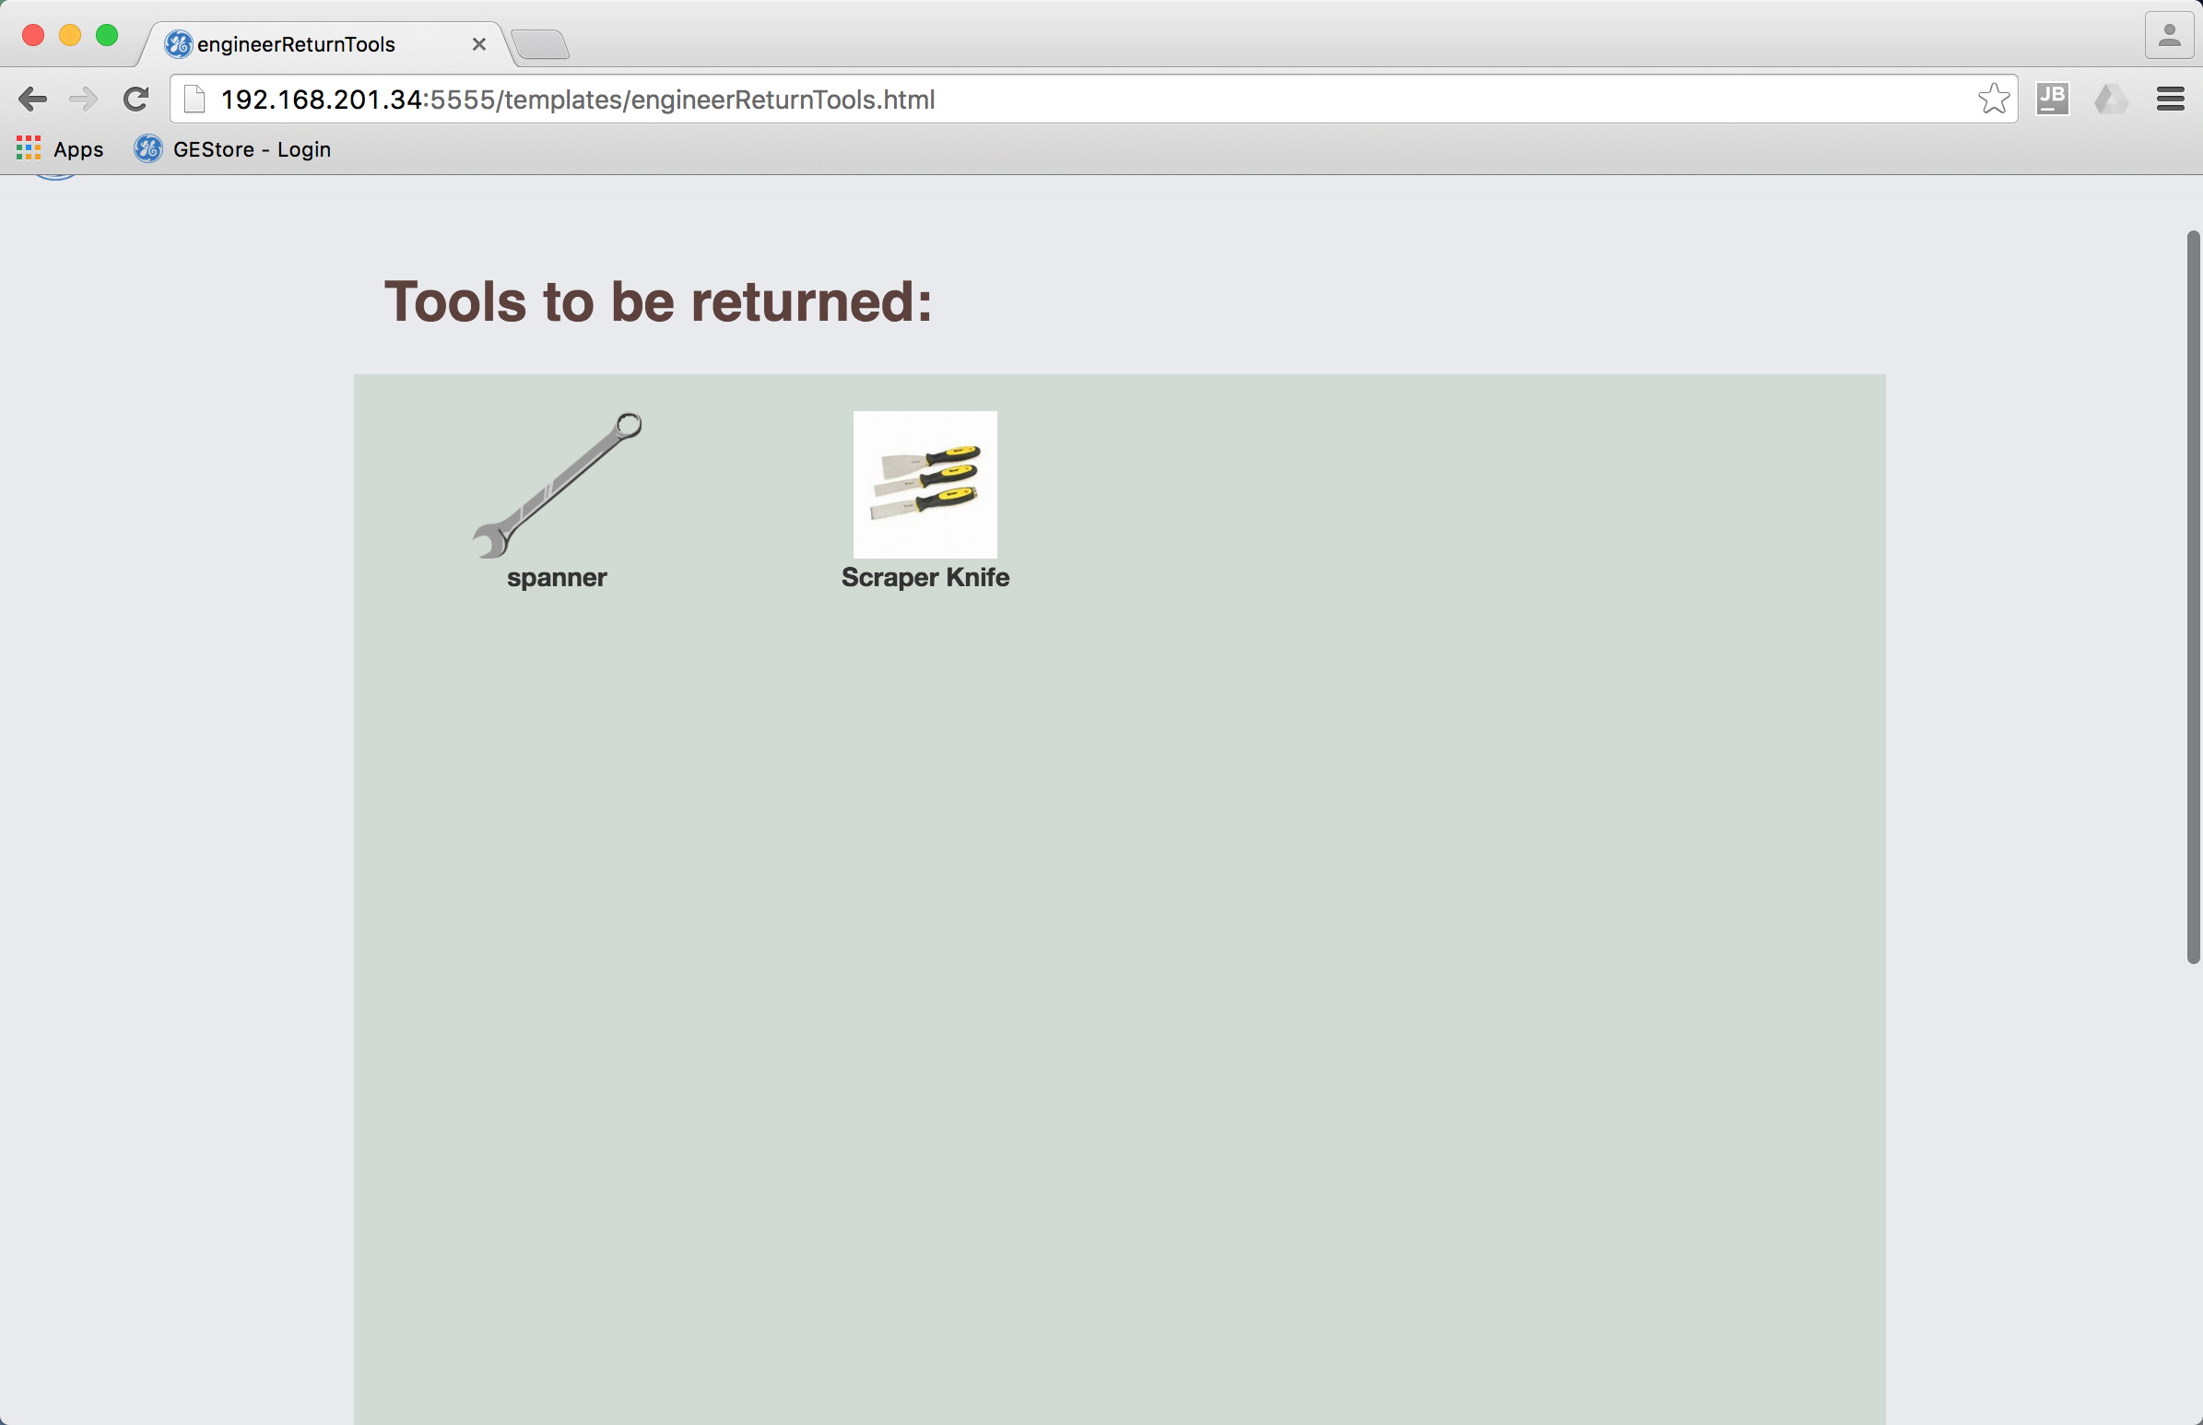 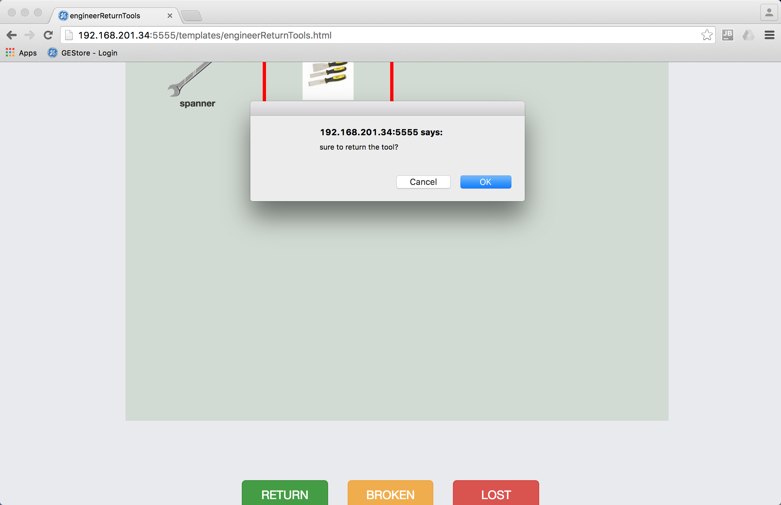

## 4.4 Interface for tool keeper

The tool keeper can check the process of the service, accept a task and do all the on-site work when connected to the server.

1. Login from the same page with a keeper account.
2. Check new requests and click one of them. The tool keeper can only see requests with a box of tools of high value. Requests have been accepted by other keepers are also not shown here.

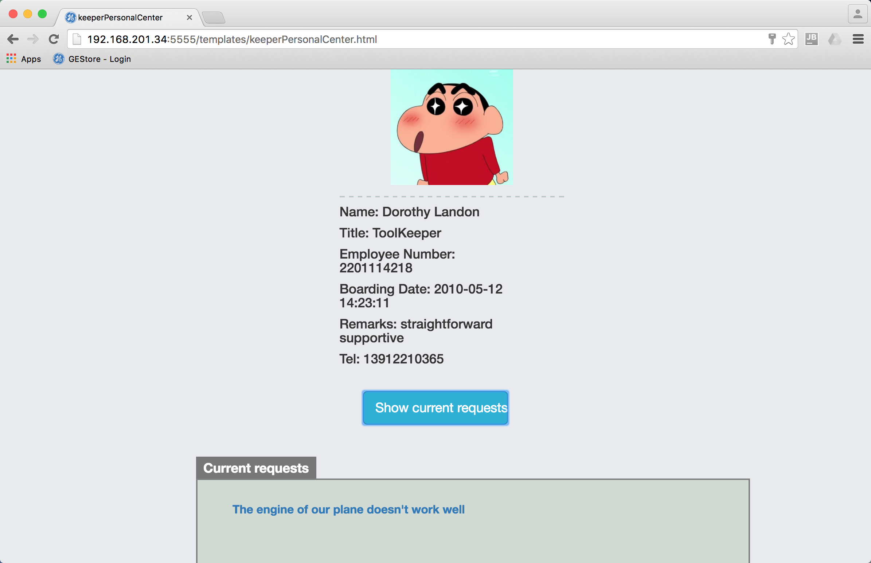

1. The keeper can accept the request on the following page after the value of tools has been marked high by system. The button “ONSITE” will appear after he accepted the request. Click this button when onsite task begins. The system time is automatically recorded and the system will ask to scan the RFID on toolbox and enter in location[7].

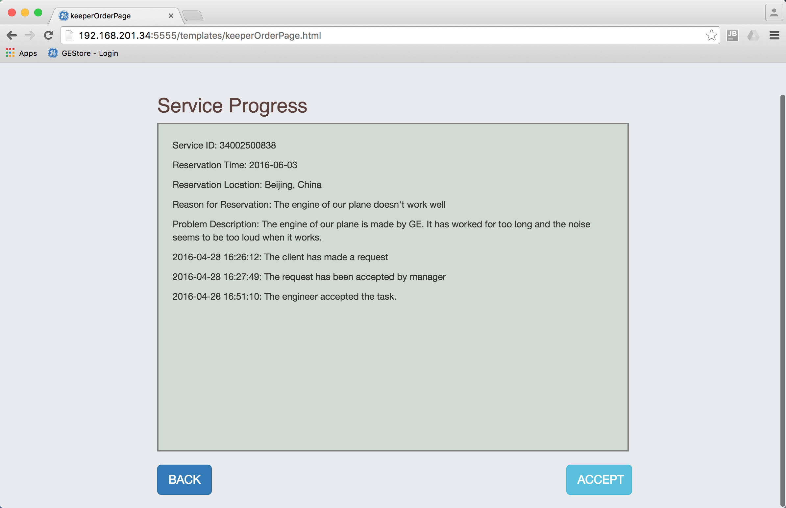 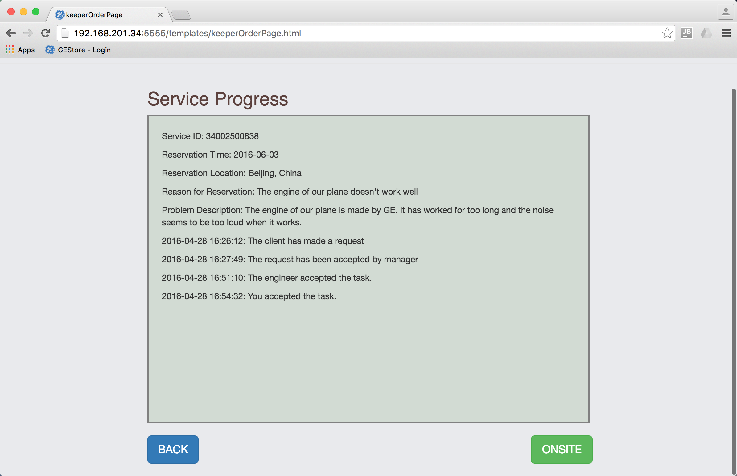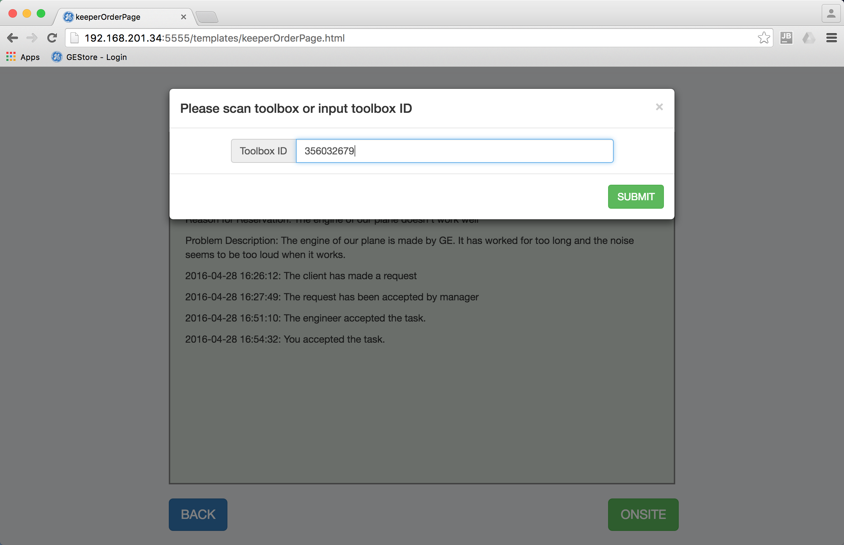 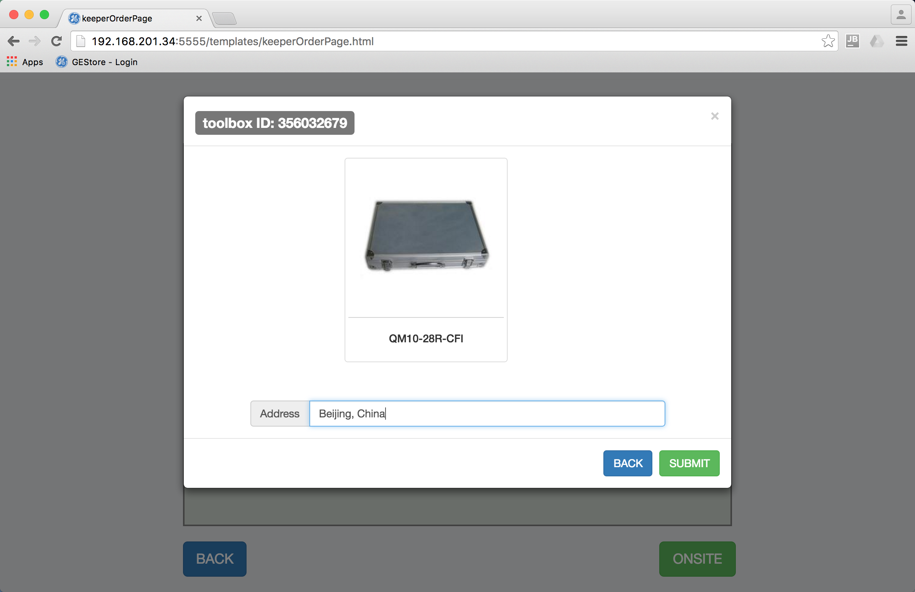

1. Click “Lease Tools” to lend tools to engineers. Scan the ID of tools or engineers, whose information would be shown on screen when scanned, and then, JUST click “CONFIRM”, all the information will be recorded by system and no other manual operation needed. If you scan more than one engineer ID or scan the same tool for more than once, only the last will count. Be aware that you should at least put in one ID of tools and engineers when you borrow the tools, or you will not succeed and the alert comes.

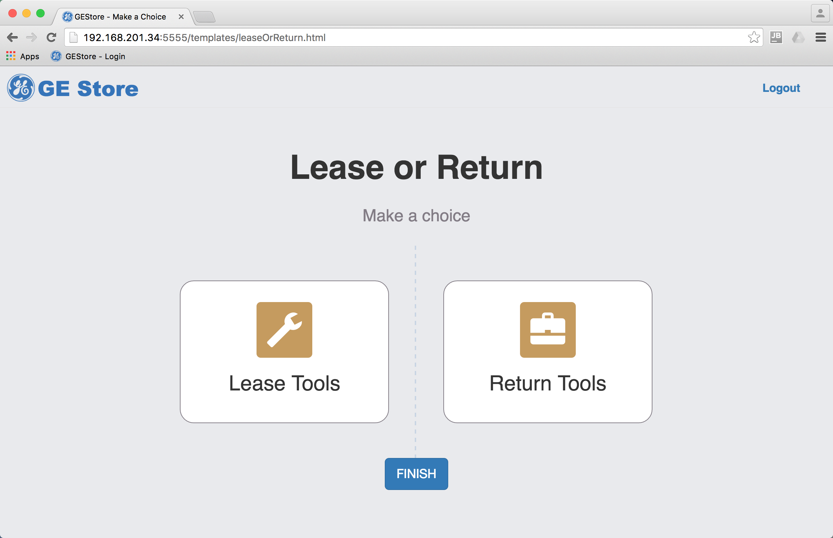 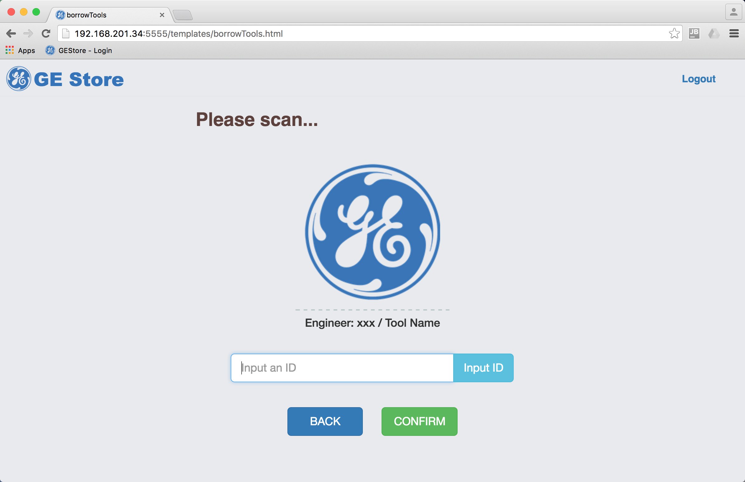

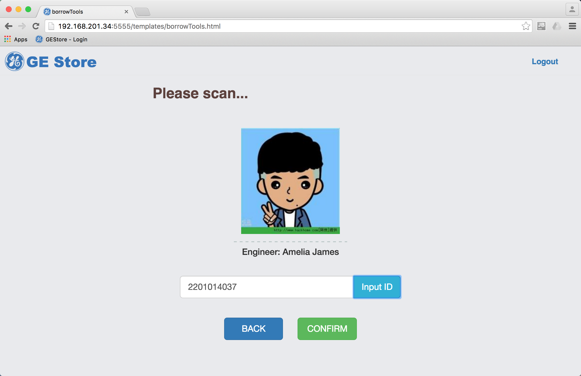 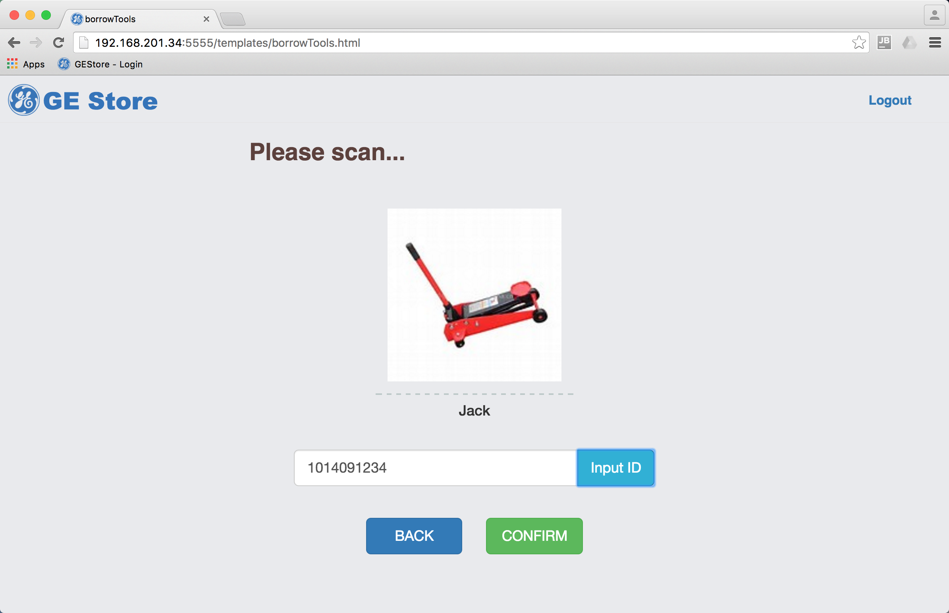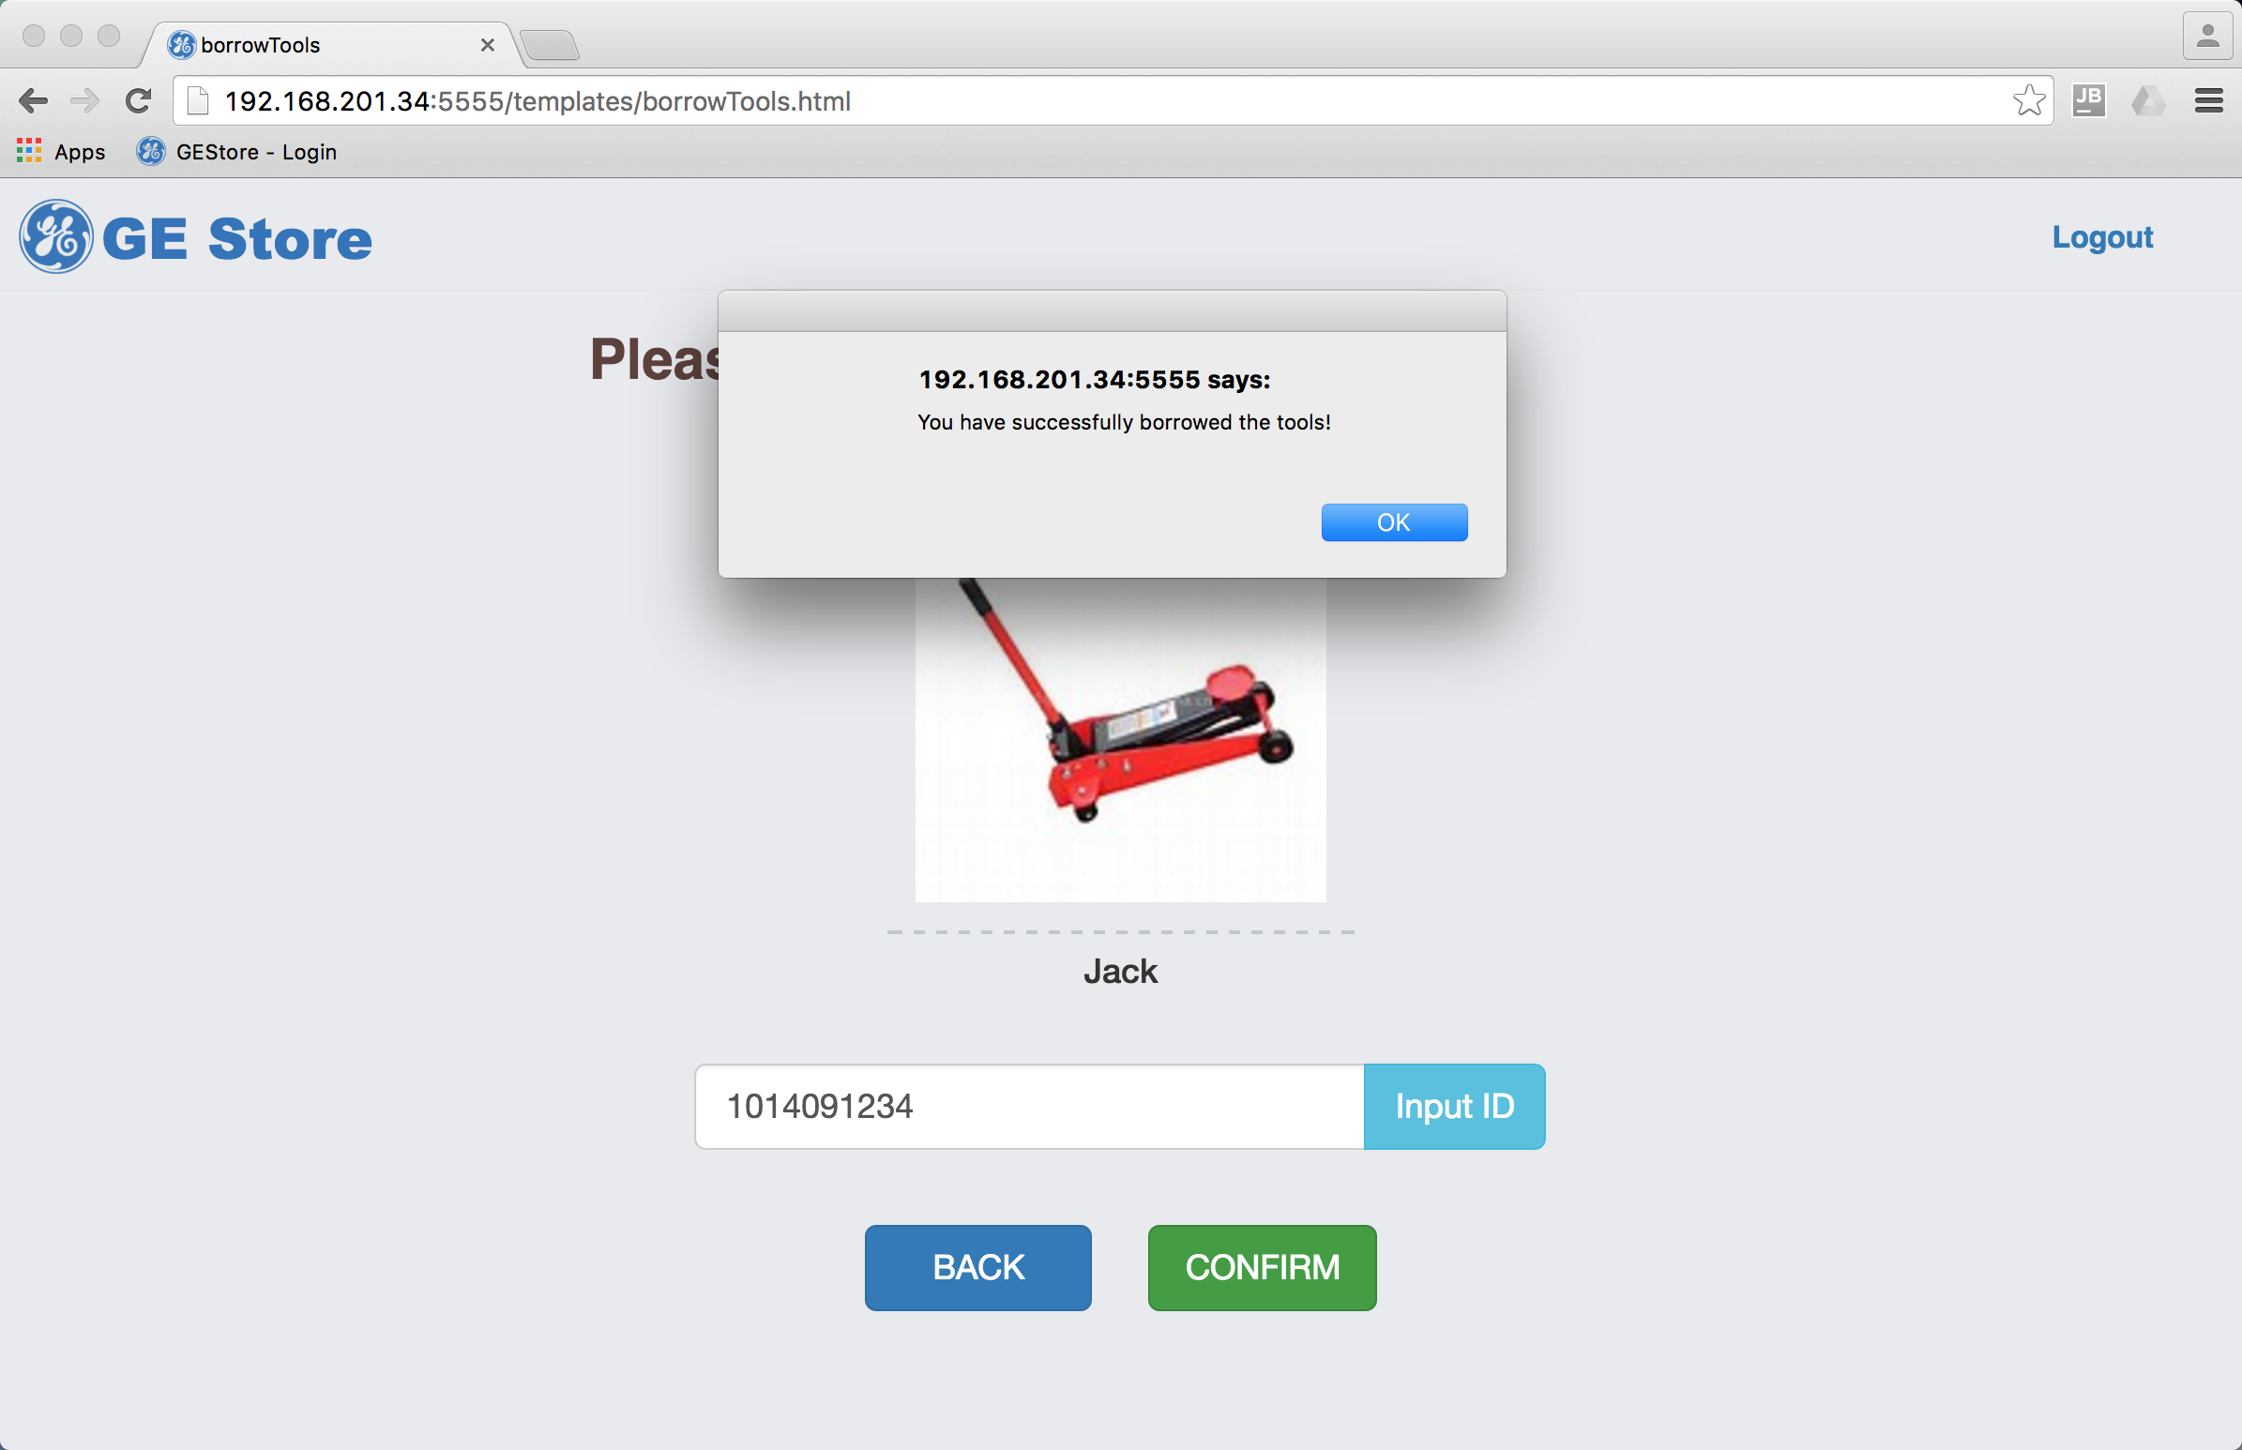

1. Click “Return Tools” to return tools. Scan the ID of a tool or an engineer. All tools related will appear. Click to choose one of them and click “Return”, ”Broken” or ”Lost” to update the information. If the status is “Broken” or “Lost”, some remarks are required to explain the reason.

 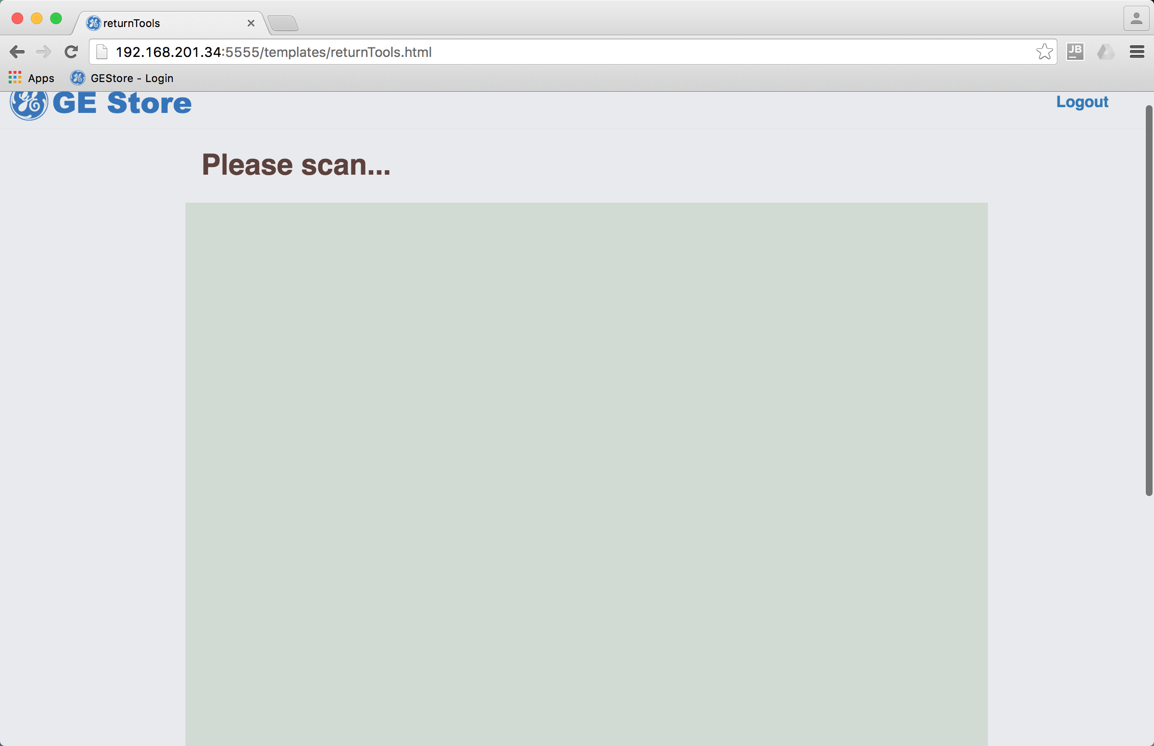 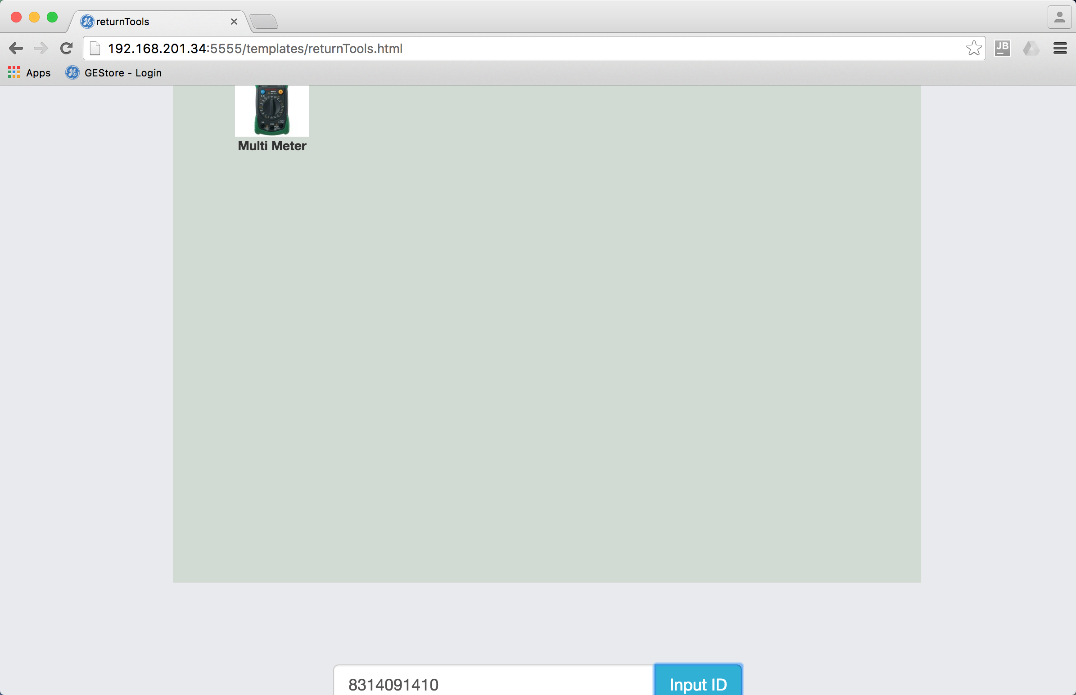 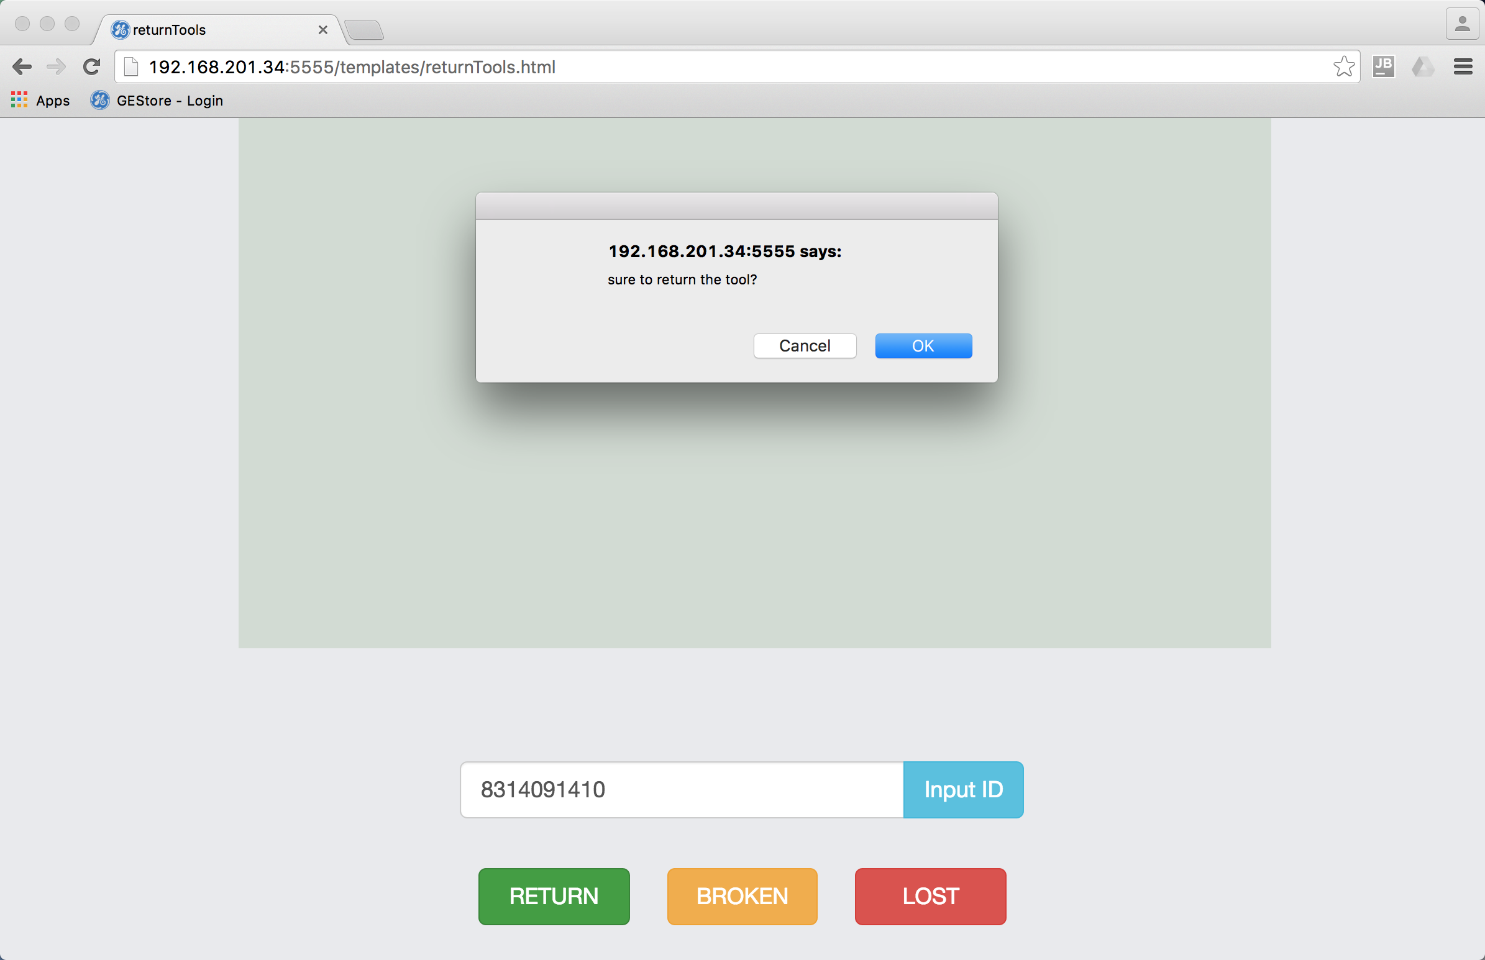 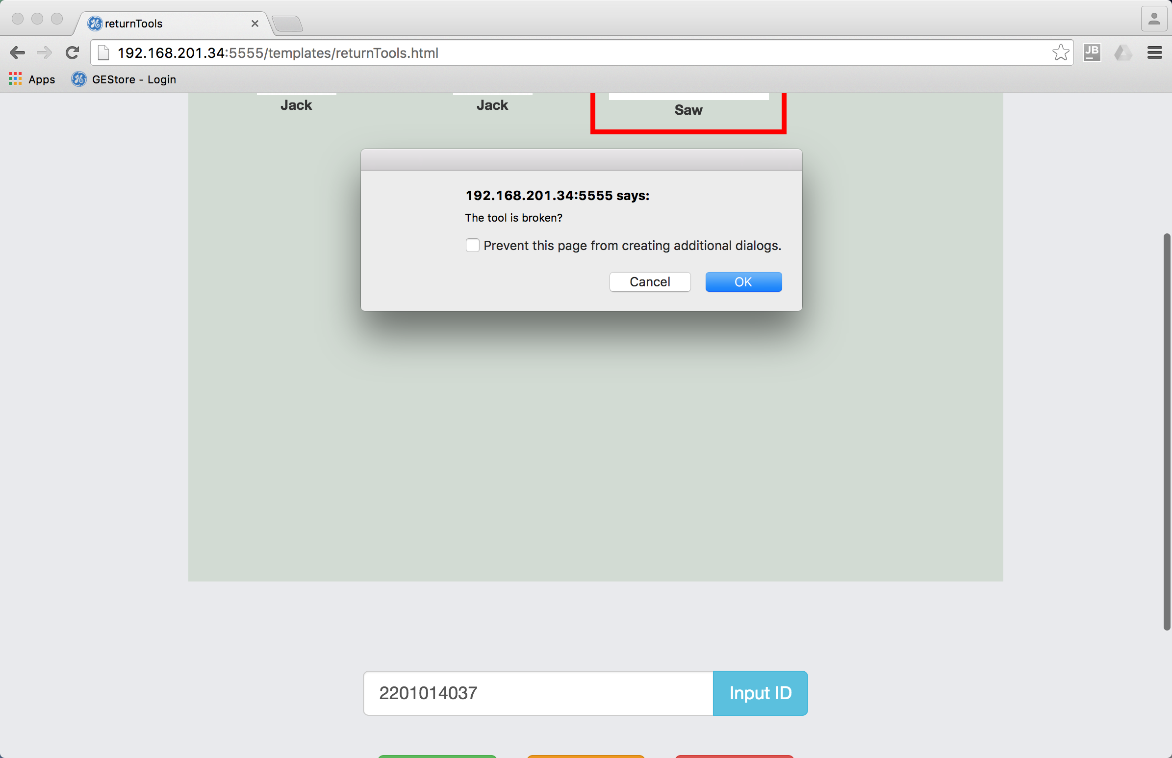 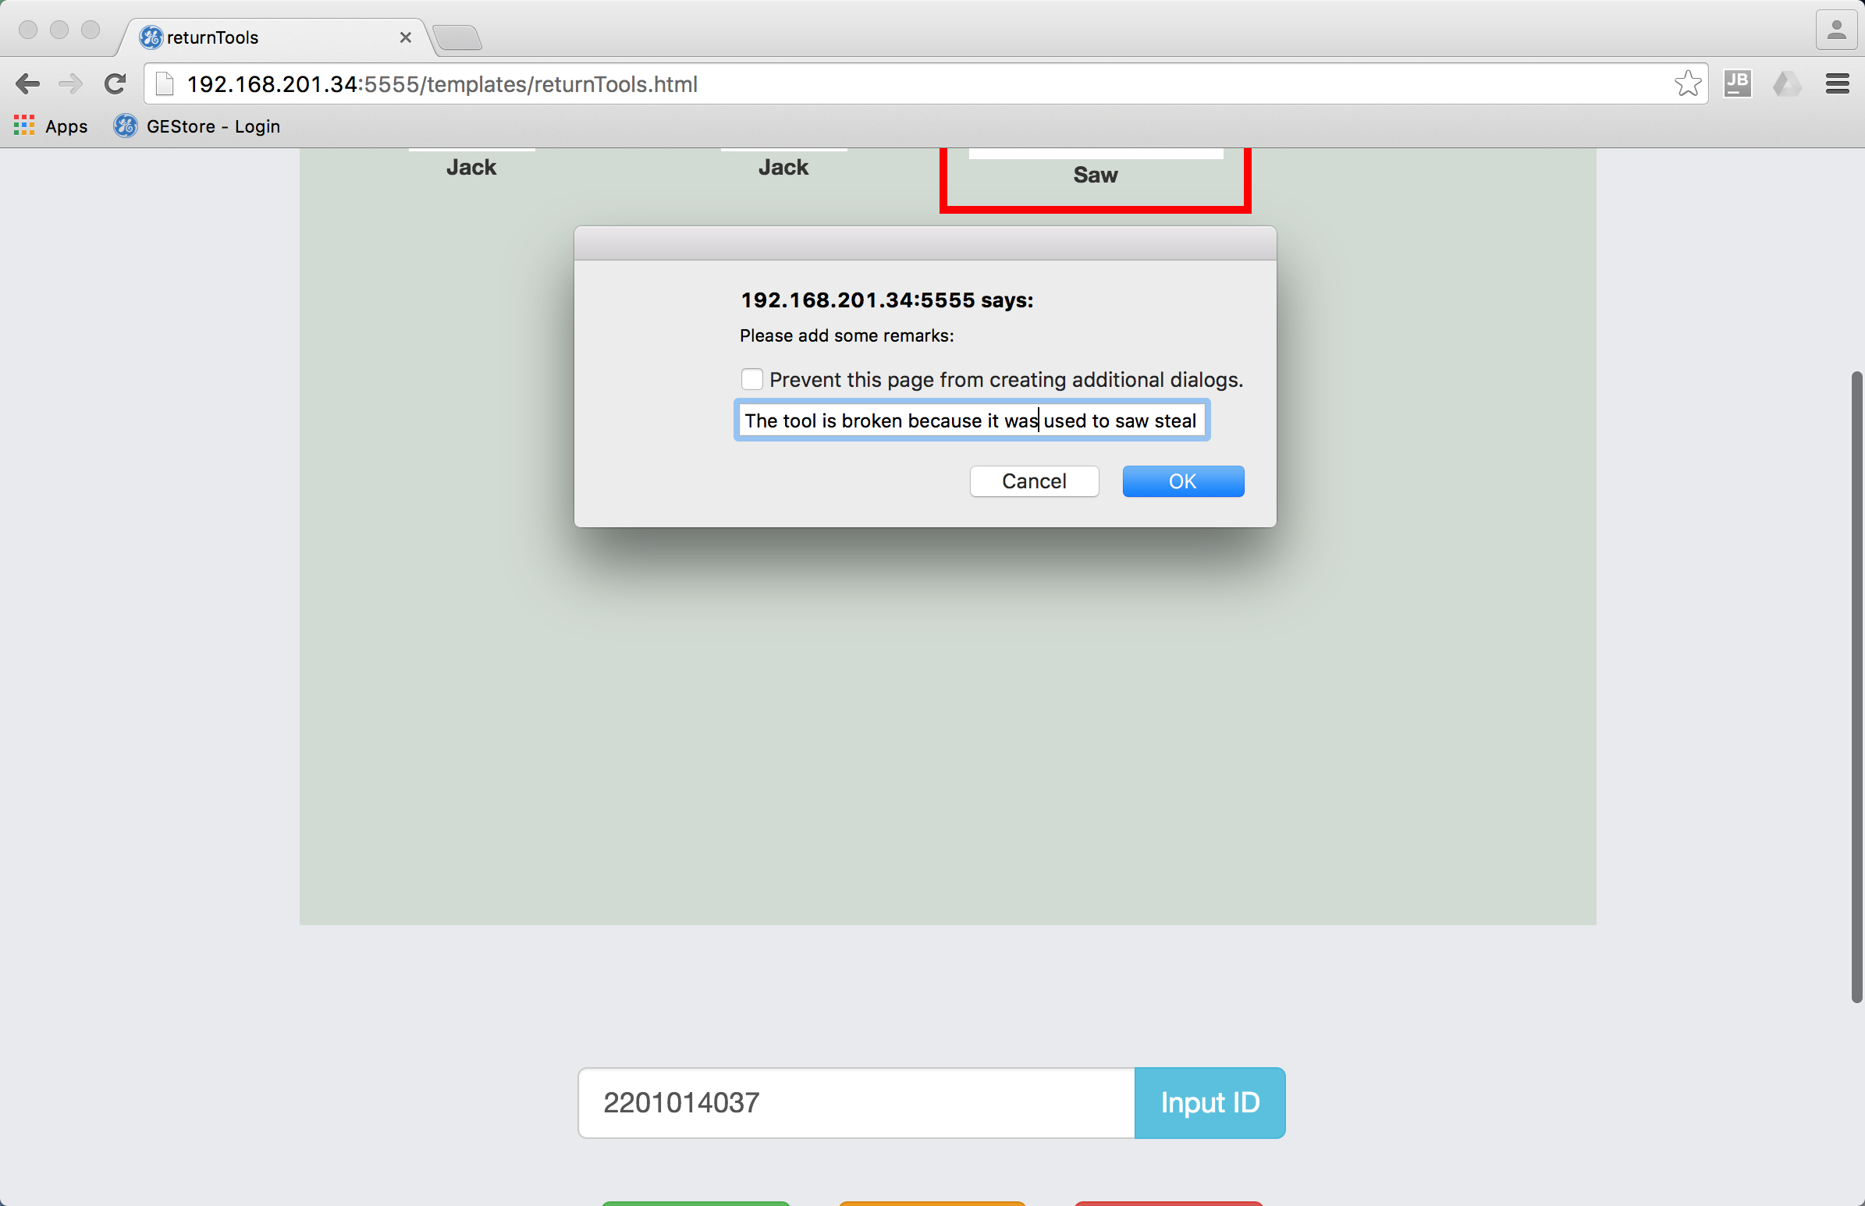

1. Click “FINISH” to confirm the task has been finished. The system will ask whether the task has been finished, if you choose “Cancel”, the system will think you would continue to do this task some time later.

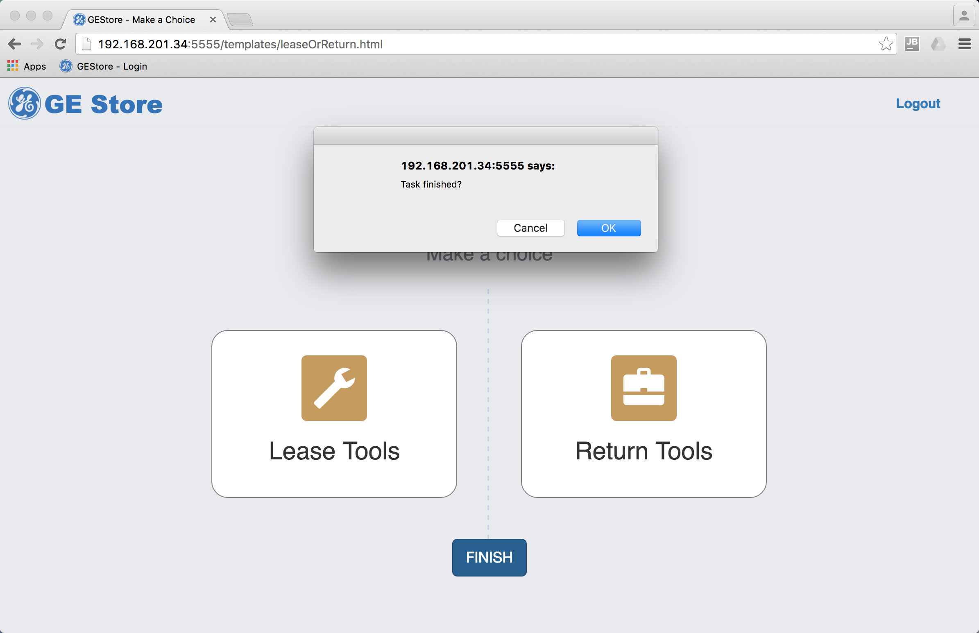 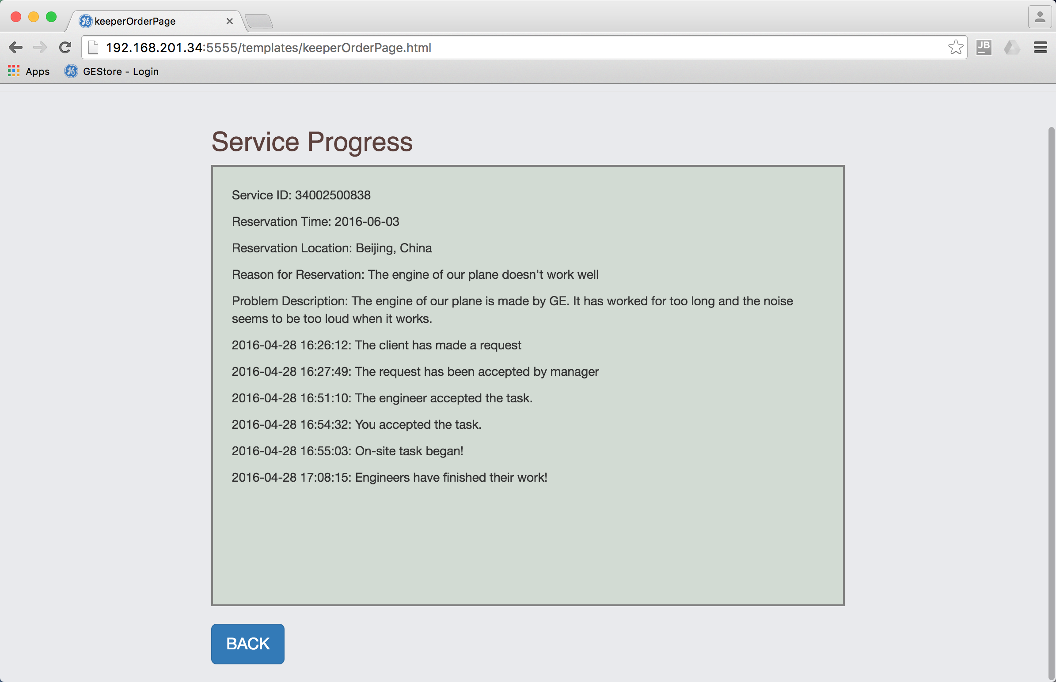

# 5. Summary

It’s a pity we don’t have enough time to implement all the functions we mentioned in our PPT. But this app can already show our big idea. This could be a good way to manage various resources in company, not only tools, but also stationary, equipment, human resources, etc.

1. It is better to show the requests automatically. We implement the function in this way due to the time limit.
2. In real life, these things are not work for one person. We just put all functions here to show the idea in demo. And some functions in PPT are not implemented due to time limit. Below are all the functions we have implemented.
3. The manager will see the button “ACCEPT” only after the client has made the request, and then the button disappears. The engineer will see “ACCEPT” only after the manager has accepted the request. The tool keeper can see “ACCEPT” only after the engineer has made a reservation for tools and the system has decided the value of the tools is high, in which situation a tool keeper is needed. The process flows like that, all information recorded. Therefore, the whole system is closely integrated as a whole.
4. The threshold between high and low can be changed by manger.
5. Up to now, the reservation has been made, and the tool center will send toolbox. The engineer can just go on site for work. Due to time limit, we hasn’t included the part of tool center in our demo. The tool center should play a role in the process in real life.
6. Though we let the engineer update the status of tools by himself/herself here, the tool center will check whether he/she has filled in the right status on receiving the toolbox. As a demo, we don’t include the role of tool center here.
7. In demo we don’t have the hardware, so put in an ID of toolbox manually. In the next webpages, you are also supposed to put in ID of engineers and tools manually. But in reality, this should be done by scanning the RFID.